Rheumatoid Arthritis Virus (RA-1)
Description:
- species of Parvoviridae, classificiation under Parvovirinae and Parvovirus tentatitive.
- ssDNA, monopartite, icosahedral capsid, naked
- 20-26 nm in diameter, complement

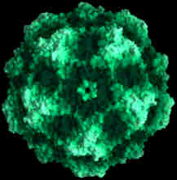

Power:
Offenses:
Attacks: RA-1 appears to affect synovial cells in humans
Outcome: Rheumatoid arthritis
Speed: Bit fast, 5-10 days in mice, unknown for humans
Defenses:
Vaccines: none
Behavioral: route of transmission unknown
Treatment: none
Game action: Disability – skip every other turn due to the pain it takes you to move your joints.
“RA-1 likes to make her residents have fun.”

