MI155A Humans and Viruses
6 units
Autumn 2020

The COVID-2019 pandemic has profoundly impacted every aspect of our lives. We are constantly barraged with information from the media and elsewhere. But what do we really know about viruses?

The Humans and Viruses course sequence is offered this coming autumn and winter quarters. First offered in 1983, Humans and Viruses provides an immersive look at Human Virology from basic concepts to breaking news. These courses cover a wide range of perspectives including epidemiology, molecular biology, clinical sciences, public health, social sciences, history, and the arts.
Never has this material been more timely or more relevant.
Graduates of Humans and Viruses have become leaders in the fields of health policy, infectious disease, and clinical medicine. Many work in medicine, academia, and government. And many are at the forefront in the efforts to understand and contain the coronavirus pandemic.
These unique courses are applicable to students in all academic years who are willing to take a deep dive into this fascinating field.
This quarter, Humans and Viruses will be offer in an online format. Class sessions will be primarily devoted to a highly interactive lecture format. Student performance will be assessed using weekly problem sets, along with a series of project based assignments.
There are no course prerequisites.

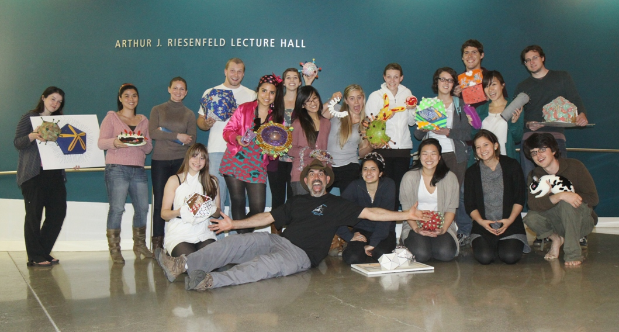

Robert David Siegel, MD, PhD

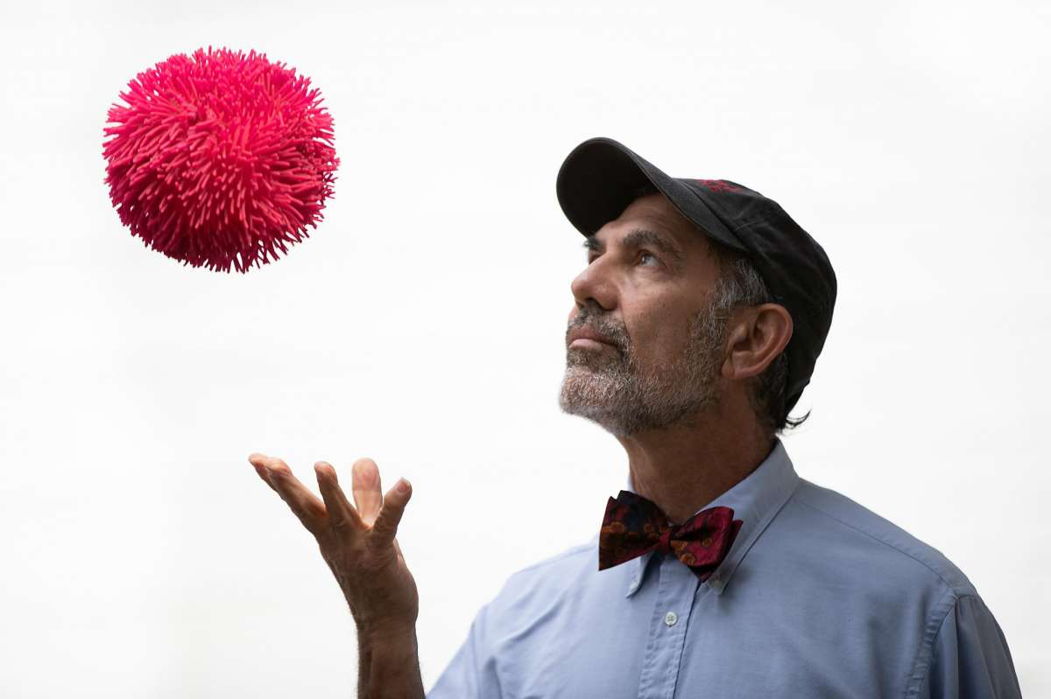

Robert Siegel is a professor at Stanford in the Department of Microbiology and Immunology. He has secondary appointments in the Center for African Studies, the Master of Liberal Arts Program, the Program in Human Biology, and the Woods Institute for the Environment. Bob’s courses focus on virology and infectious disease, genetics and molecular biology, biogeography and ecology, Darwin and evolution, and photography.

Dr. Siegel has been teaching about viruses for 4 decades – a period covering a number of devastating viral pandemics as well as an explosion of knowledge regarding the nature of these remarkable subcellular pathogens. For 20 years, he ran the required preclinical curriculum related to microbiology and infectious disease at Stanford School of Medicine. He is frequently interviewed by the news media on matters related to the COVID19 pandemic.

Professor Siegel is the recipient of numerous teaching and advising awards including the Northern California Phi Beta Kappa Teaching Award, the ASSU Teaching Award, the Gores Award for Excellence in Teaching.

Dr. Siegel has served in an advisory capacity for various international NGOs, organizations, and projects including: The Discovery Channel, Wonderfest, FACE AIDS, Support for International Change, Ocean Medicine Foundation, Free the Children, Sage Bionet, and Teach AIDS. He has volunteered as a docent at Jasper Ridge and Año Nuevo State Park.
He is a published photographer and poet. He has completed photographic explorations of seven continents and has taught field courses on six. Numerous samples of his photographic work can be found at:
http://web.stanford.edu/~siegelr/photo.html

He was also the second Stanford Tree.

Below are a couple of recent stories about Dr. Siegel.
https://www.sfchronicle.com/science/article/On-the-front-lines-The-dynamic-collaboration-15173260.php
http://web.stanford.edu/~siegelr/bob/bob%20published/Robert%20Siegel%20PUNCH%20July%202020.pdf

