The Pharmacokinetic and
Pharmacodynamic Basis of
Target Controlled Infusion

Steven L. Shafer, M.D.

Staff Anesthesiologist, Palo Alto VA Health Care System
Associate Professor of Anesthesia, Stanford University

Address:
Anesthesiology Service (112A)
PAVAHCS
3801 Miranda Ave
Palo Alto, CA 94304
USA

Phone 650 852-3419
FAX: 650 852-3414
E-mail: Steven.Shafer@Stanford.Edu

Supported in part by the Merit Review Program of the Department of Veterans Affairs. Portions previously published by Steven L. Shafer (used with permission).

With the introduction of the Diprifusor® in Europe by Zeneca Pharmaceuticals there is increasing interest in Target Controlled Drug Delivery. Although the Diprifusor is the first commercially produced target controlled infusion device, the concept was introduced in 1968 by Krüger-Theimer. In 1981 Schwilden expanded on these efforts to describe a general method of rapidly reaching and maintaining a constant plasma drug concentration. The first implementation of Computer Assisted Total Intravenous Anesthesia was the CATIA device developed by Schüttler, Schwilden, and Stoekel and reported in 1983. The technology rapidly spread, and in 1985 Ausems, Stanski, and Hug reported on their work with the “TIAC” system in the Netherlands while Avis, Reves, and colleagues reported on their “CACI” system in the United States. In 1998 closed form mathematical solutions for target controlled delivery systems were published by Shafer and Jacobs and implemented in the “STANPUMP” and “CACI II” systems, respectively. By the time the first prototype of the Diprifusor was introduced in 1990 by White and Kenny the technology was mature. It is primarily because of regulatory issues that the commercial introduction has lagged so far behind the scientific developments.

Pharmacokinetics and pharmacodynamics provide the scientific foundations of target controlled drug delivery. This review will first present the basic concepts of pharmacokinetics and pharmacodynamics. It will then develop the mathematical model that is used by most target controlled infusion systems. In the process, it will discuss the state-of-the-art in target controlled drug delivery, and the type of advances that can be expected in the next generation of target controlled delivery systems.

Pharmacokinetic Principles
The fundamental pharmacokinetic concepts are volume and clearance. Volumes represent the apparent dilution of a drug from the concentrated form in the syringe to the more dilute concentration in the blood or plasma . It is as if the drug were pored into a bucket, as shown in figure 1. If we call X the amount of drug added to the bucket, and V the volume of the bucket, then by definition the concentration in the bucket is X/V. However, typically we don’t know V, but it can be calculated with a simple experiment. If we know X, and we measure concentration, then the volume can be solved for:
$$V=\frac{X}{C}$$
This simple relationship offers important insight. Let's assume the size of the bucket is constant (a very reasonable assumption for most drugs). If you double the dose, you will double the concentration. This is the principle of “linearity”: concentrations change in proportion to dose.

$\text{Extraction Ratio}=\frac{C_{\text{inflow}}−C_{\text{outflow}}}{C_{i\text{nflow}}}$Clearance is the body's ability to remove drug from the blood or plasma. Clearance has units of flow: volume/time. Clearance is thus the flow of blood or plasma, expressed as volume per unit time, from which drug has been irreversibly removed, as shown by Q in figure 2. Clearance describes an intrinsic capability of the body, not an actual rate of drug removal. The rate of drug removal depends on the concentration of drug in the body. For example, if the body has a clearance of 1 liter/minute for a particular drug, the actual rate of drug removal will be 0 if no drug is present in the body, 1 mg/min if the plasma drug concentration is 1 mg/liter, 100 mg per minute if the plasma drug concentration is 100 mg/liter, etc. For drugs with linear pharmacokinetics, the clearance does not depend on the concentration of drug. The actual rate at which a drug eliminated is the product of the plasma drug concentration and the clearance. Note that in figure 2 clearance, Q, is the same as the flow to the clearing organ. This is the case because the drug concentration is 0 in the outflow from the organ. In reality, the clearing organ is never 100% efficient, and clearance is actually Q (flow to the organ) times the extraction ratio (the percent of drug flowing into the organ that is actually cleared). The extraction ratio is calculated as:

We can combine the bucket model with the flow model, and get the classic “one compartment” pharmacokinetic model, as shown in figure 3. This model has a single volume, V, and clearance, Q. What are the properties of this simple model?

Many processes happen at a constant rate, like the power consumption of a clock, or the rate at which we age. These processes are called zero-order processes. Constant rate intravenous infusions are also zero-order processes. For a zero-order process, the rate of change (dx/dt) is simply a constant, here called k:

$$\frac{\text{dx}}{\text{dt}}=k$$

The units of k are amount/time. We can calculate the amount, x, at time t, (mathematically donated as x(t)), as the integral of the above equation from time 0 to time t:
$$x(t)=x_{0}+\text{kt}$$

where x₀ is the value of x at time 0. This is, of course, the equation of a straight line with a slope of k and an intercept of x₀.

Other processes occur at a rate proportional to the amount. For example, the rate at which we pay interest on a loan is proportional to the outstanding balance. The banker doesn't say: “You'll pay $25 in interest every month, no matter how much you borrow.” (My response would be: “fine, I'll borrow a billion dollars.”) Instead, he may say: “You will pay 1% of the outstanding principle every month.” This is a first order process. The mathematics are only slightly more complex for a first-order process compared with a zero-order process. The rate of change for a first-order process is proportional to the amount:
$$\frac{\text{dx}}{\text{dt}}=\text{kx}$$

Here, the units of k are simply 1/time, since the x to the right of the “=” already brings in the units for the amount. Again we can calculate x(t) as the integral of the above equation from time 0 to time t:
$$x(t)=x_{0}e^{\text{kt}}$$

where x₀ is the value of x at time 0. If kt > 0, x(t) increases exponentially. If kt > 0, x(t) decreases exponentially. In pharmacokinetics, k is negative becauseconcentrations decrease over time. To simplify the upcoming calculations, we will express the relationship between x and t by removing the minus sign from k, and expressing it explicitly in the equation. Thus, the equation we will explore will be:
$$x(t)=x_{0}e^{−\text{kt}}$$

Figure 4 is a graph showing the relationship between x and time, as described by the above equation (where k is positive, so -kt is < 0). Such a graph might describe the plasma drug concentrations after bolus injection in our 1 compartment model. Note how the concentrations continuously decrease, and the slope continuously increases, as the levels fall from x₀ to 0. The levels never actually reach 0, but approach 0 as t → ∞.

If we take the natural logarithm* of both sides of the above equation, we get:
$$\begin{matrix}\text{ln}\left(x(t)\right)=\text{ln}\left(x_{0}e^{−\text{kt}}\right) \\ \text{ln}\left(x_{0}\right)+\text{ln}\left(e^{−\text{kt}}\right) \\ \text{ln}\left(x_{0}\right)−\text{kt}\end{matrix}$$

This is the equation of a straight line, where the vertical axis is $\text{ln}\left(x(t)\right)$, the horizontal axis is t, the intercept is ln(x₀) and the slope of the line is -k. Thus, the graph of the logarithm of the amount vs. time is a straight line, as shown in figure 5.

How long will it take for x to go from x₀ to x₀/2, i.e., for the x to fall by 50%? We can relate the slope of the line (-k) to the change in x and t as follows:
$$\text{k = }\frac{Δx}{Δt}\text{ = }\frac{\text{ln}\left(x_{0}\right)−\text{ln}\left(\frac{x_{0}}{2}\right)}{t_{1/2}}$$

where t _{½} is the time required for a 50% decrease in x. We can simplify the numerator to:
$$\begin{aligned}\text{ln}\left(x_{0}\right)\text{-ln}\left(\frac{x_{0}}{2}\right)\left(\frac{x_{0}}{\frac{x_{0}}{2}}\right) \\ \\ \text{ ln}\left(2\right) \\ \text{ 0}\text{.}\text{693}\end{aligned}$$

This relates the slope, k, to the time required for a 50% change, t_{½}:

$$\text{k = }\frac{\text{ 0}\text{.}\text{693 }}{t_{\text{1/2}}}$$

so if we measure t_{½}, the time it takes for x to fall by 50%, then we know the exponent, k, as calculated above. If we know k, the exponent, then the time it will take for x to fall by 50% is simply:
$$t_{\text{1/2}}\text{ = }\frac{\text{ 0}\text{.}\text{693 }}{k}$$

Thus, exponential functions are intrinsic to solving for the amount, x, at time t, when dealing with first order processes, and logarithms are useful to transform the exponential curve into a straight line, which can then be more easily manipulated.

Let's now return to the simple one compartment model, shown in figure 3. If we inject x₀ units of drug into this model, then the concentration s the amount of drug present, x, divided by the volume of the bag, V. (We call the initial injection x₀ to note that it is the amount present at time 0). Let’s call the rate of flow into a completely efficient clearing organ Q. The rate at which drug (x) flows out of this volume is the rate of fluid flow, Q, times the concentration of drug in the fluid, C. Thus, the rate at which drug flows out of the bag is:
$$\frac{\text{dx}}{\text{dt}}\text{ = Q x C}$$

This is a first-order process. We can find k, the rate constant, by substituting x/V for C in the above equation:
$$\begin{aligned}\frac{\text{dx}}{\text{dt}}(\text{rate})=\text{QC} \\ =Q\frac{x}{V} \\ =\frac{Q}{V}x \\ =\text{kx}\end{aligned}$$

The last line above, “= k x”, comes from the definition of a first order process given previously, so that we can inspect the equation and figure out what k is. Obviously, k must equal Q/V. Rearranging this yields a fundamental pharmacokinetic statement:
Q (clearance) = k (rate constant) × V (volume of distribution)

If we know the flow out of the compartment (clearance), and we know the volume of the compartment, we can calculate k as Q/V. We can then calculate the half-life of drug in the bag as 0.693/k. This leads to two useful insights: If the volume remains constant, then as Q (clearance) increases, k increases, and the half-life decreases. If the clearance remains constant, then as V (volume) increases, k decreases, and the half-life increases.

Let A = x₀/V, where A is the concentration at time 0, x₀ is the initial dose of drug and V is the volume of the bag. The plasma concentrations over time following an intravenous bolus of drug are then described by an equation of the form:

C(t) = Ae ^{-kt}.

This is the commonly used expression relating concentration to time and initial plasma concentration, and the rate constant. It defines the “concentration over time” curve for a 1 compartment model, and has the shape of the curves seen in figures 4 and 5.

We can calculate the flow, Q, in one of two ways. First, as noted above, if we know V and k, then Q = k V. However, a more general solution is to consider the integral of the concentration over time curve, known in pharmacokinetics as the “area under the curve” or “AUC” for short. This integral can be solved as:
$$\text{AUC =}\underset{0}{\overset{¥}{ò}}\text{ A}e^{\text{-kt}}\text{dt = }\underset{0}{\overset{¥}{ò}}\frac{x_{0}}{V}\left(e^{−\frac{Q}{V}}\right)\text{dt =}\frac{x_{0}}{V}´\frac{V}{Q}=\frac{x_{0}}{Q}$$

Thus, Q = x0 /AUC, showing that the clearance equals the dose divided by the area under the curve. This is a fundamental property of linear pharmacokinetic models. It directly follows that AUC is proportional to dose for linear models (i.e., models where Q is constant).

Let's say that you start giving an infusion at a rate of I (for Input) to a person who has no drug in his or her body. It's obvious that the plasma concentration will rise as long as the rate of drug going in the body, I, exceeds the rate at which drug leaves the body, C × Q. Once, I = C × Q, drug is going in and coming out at the same rate, and the body is at steady state. This raises two questions: 1) what is the eventual concentration? and, 2) how long will it take until I = C × Q?

To answer the first question, consider that when the body is in equilibrium, the rate of drug going in must equal the rate of drug coming out, and thus:
I (the rate of drug going in)= C (the steady state concentration) × Q (clearance).
We can rearrange this equation as C = I/Q, the ratio of the infusion rate and the clearance. Thus, the eventual concentration is the infusion rate divided by the clearance.

C = I / Q is satisfyingly similar to the equation describing the concentration following a bolus injection: C = x₀ / V. This suggests another way to think about volume and clearance: volume relates initial concentration to the size of the initial bolus, and clearance relates steady-state concentration to the infusion rate. One consequence is that the initial concentration following a bolus is independent of the clearance, and the steady state concentration during a continuous infusion is independent of the volume.

As far as how long it will take to reach steady state, the answer is simple: ∞. The reason is that the steady state concentration is asymptotically approached, but never reached. However, we can determine how long it will take to reach any given fraction of the steady state concentration. We have already defined the rate of change for a zero order process when drug is only leaving, but how about when drug is going in at the same time? In this case, the rate of change, dx/dt, is the difference between the rate of drug flowing in and the rate of drug flowing out:
$$\frac{\text{dx}}{\text{dt}}\text{ = }I\text{ - kx}$$

where I is the rate of drug going in, x is the amount of drug present at time t, and k x is the rate of drug coming out. To find x(t), we need to integrate this from time 0 to time t, knowing that x(0)=0. The integral is:
$$x(t)\text{ = }\frac{I}{k}(\text{1 - }e^{\text{-kt}})$$
As t →∞, , e^{-kt} → 0, and the above equation reduces to:
$$x(∞)\text{ = }\frac{I}{k}$$
Let's say that we want to get to 50% of that amount, i.e., x(∞)/2. From the above equation, we know that x(∞)/2 = I/(2k). Substituting I/(2k) for x(t) into equation 1, we get:
$$\frac{I}{\text{2K}}\text{ = }\frac{I}{K}(\text{1 - }e^{\text{-kt}})$$

Solving this for t, we get: ln(2)/k. As you may recall, we previously showed that the half-life, t_{½}, following a bolus injection was ln(2)/k. Here we again have a satisfying parallel between boluses and infusions: with an infusion, the time to get to 50% of the steady state concentration is 1 half-life. We can similarly show we will get to 75% of the steady state concentration following 2 half-lives, 88% following 3 half-lives, 94% following 4 half-lives, and 97% following 5 half-lives. Usually, by 4-5 half-lives, we consider the patient to be at steady state, although they are a few percent (but an infinite time!) away from truly being at steady state.

Having developed fundamental relationships for a one compartmental model, we can calculate out the bolus dose and infusion rate to instantly achieve and maintain a steady drug concentration. Lets call the target concentration C_{T}. By rearranging the definition of concentration the amount of drug that must be injected is C_{T} × V. To maintain the concentration at C_{T} you must continuously infuse drug at the rate it is leaving, which is C_{T} × Q. Therefore, the maintenance infusion rate must be C_{T} × Q. These are the standard pharmacokinetic equations all physicians are taught in medical school. We will now explore why they don’t work for anesthetic drugs.

The plasma concentrations over time following a bolus of an intravenous drug actually resemble the curve in figure 6. As before, the concentrations decline over time but the curve continuously becomes less steep (i.e., the slope continuously increases). However, unlike figure 5, which is linear when the Y axis is on a log scale, figure 6 is curved on a log scale until the very last portion, which is “log-linear.” Additionally, there are three distinct phases can be distinguished in figure 6. There is a rapid “distribution” phase (solid line) that begins immediately after the bolus injection. This phase is characterized by rapid movement of the drug from the plasma to the rapidly equilibrating tissues. Often there is a slower second distribution phase (dashed line). During this slower distribution phase drug continues to move into slowly equilibrating tissues, while drug returns to the plasma from the most rapidly equilibrating tissues (i.e, those that reached equilibrium with the plasma during the earliest phase). The log-linear terminal phase (dotted line) is often called the “elimination phase” because the primary mechanism for decreasing drug concentration during the terminal phase is drug elimination from the body. This term is a bit misleading, because elimination from the body starts from the moment of injection. During this “terminal phase” drug returns from the rapid and slow distribution volumes to the plasma, and is permanently removed from the plasma by metabolism or renal excretion.

Figure 7 shows an example of the concentrations following bolus injection for 4 anesthetic drugs: fentanyl, alfentanil, sufentanil, and remifentanil. In each case there is a rapid, intermediate, and log-linear terminal phase just like seen in figure 6.

Curves which continuously decrease over time, with a continuously increasing slope (i.e., curves that look like figures 6 and 7), can be described by a sum of negative exponentials. In pharmacokinetics, one way of notating this sum of negative exponentials is to say that the plasma concentration over time is:
$C(t)\text{ = A}e^{−αt}\text{ + B}e^{−βt}\text{ + C}e^{−γt}$
where t is the time since the bolus, C(t) is the drug concentration following a bolus dose, and A, α, B, β, C, and γ are parameters of a pharmacokinetic model. A, B, and C are called coefficients, while α, β, and γ are called exponents. Following a bolus injection all 6 of the parameters in equation 3 will be greater than 0.

So, why use these equations that describe pharmacokinetics as a sum of negative exponentials? There are 4 key reasons:
- Polyexponential equations describe the data. Pharmacokinetics is an empirical science: the models describe the data, not the processes by which the observations came to be.
- Polyexponential functions to describe the concentrations over time is these models permit us to use many of the 1 compartment ideas just developed, with some generalization of the concepts.
- Polyexponential models can be mathematically transformed into a model of volumes and clearances that has a nifty, if not necessarily accurate, physiologic flavor.
- Polyexponential models have nice mathematical properties (for example, the integral of equation 3 is A/α + B/β + C/γ).

The polyexponential model above says that the concentrations over time are the algebraic sum of three separate functions, Ae^{-αt}, Be^{-βt}, and Ce^{-γt}. We can graph each of these functions out separately, as well as their superposition (i.e. algebraic sum at each point in time) as shown in figure 8. In this figure, the curved lines shown in figures 6 and 7 are actually the sum of three lines that are each log-linear. At time 0 (t = 0), equation 3 reduces to:
$$\text{Cp}(t)\text{ = A + B + C}$$

The sum of the coefficients A, B, and C, equals the concentration immediately following a bolus. Usually, but not always, A > B > C. Thus, the initial contribution to the decrease in concentration, as shown in figure 8, is primarily from the α component, because Ae^{-αt} >> Be^{-βt} >> Ce^{-γt}.

The exponents usually differ in size by about an order of magnitude. There are several conventions to the exponential terms. I prefer to order the exponentials as α > β > γ. However, for historical reasons some individuals always call the smallest exponent β. It is usually clear from the context which exponent is the smallest. Instead of calling them α, β, and γ, some individuals refer to them as λ₁, λ₂, and λ₃. This can be used further generalize these relationships, as well be done when developing the mathematics specific for target controlled drug delivery. There is a special significance to the smallest exponent. Let λ represent the exponents, α, β, and γ. As t → ∞, λt → ∞, and e^{-λt} → 0. Now, as t → ∞, λt will go to ∞ the most slowly for the smallest value of λ, and hence e^{-λt} will go to 0 the most slowly for the smallest value of λ (i.e., γ as notated above). After enough time has passed (approximately t > (log(C) - log(B))/(β- γ), if you're curious), the values of Ae^{-αt} and Be^{-βt} are so close to 0, relative to the value of Ce^{-γt} that the drug concentrations over time are pretty much following the concentrations predicted just by Ce^{-γt}, which will appear to be a straight line, with a slope of γ, when plotted as log concentration vs time.

When the pharmacokinetics have multiple exponents, each exponent is associated with a half-life. Thus, a drug described by three exponents has three half-lives, two rapid half lives, calculated as 0.693/α and 0.693/β, and a terminal half-life (sometimes called the “elimination half-life”), calculated as 0.693/γ. In the literature you will often read about the half-life of a drug. Unless it is stated otherwise, the half-life will be the terminal half-life, i.e., 0.693/smallest exponent. With all of these half-lives, you might think that it would be hard to intuit what happens when you stop giving a drug. That is absolutely correct. As pointed out by Shafer and Varvel and Hughes et al, the terminal half-life for drugs with more than 1 exponential term is nearly uninterpretable. The terminal half-life may nearly describe, or tremendously overpredict, the time it will take for drug concentrations to decrease by 50% after drug administration. The terminal half-life places an upper limit on the time required for the concentrations to decrease by 50%. Usually, the time for a 50% decrease will be much faster than that upper limit. Hughes coined the term “context-sensitive half-time” to describe the time required for a 50% decrease in plasma drug concentration during a continuous infusion (necessarily administered by a TCI device, as discussed below). Figure 9 shows the “context sensitive half-times” for two opioids popular in anesthesia practice: alfentanil, and sufentanil. The terminal half-lives for these drugs are 2 hours and 9 hours, respectively. Even though sufentanil has terminal half-life that is nearly 5 times longer than that of alfentanil, the sufentanil concentrations will fall much faster than the alfentanil concentrations for infusions of less than 8 hours duration.

Part of the continuing popularity of polyexponential models of pharmacokinetics is that they can be mathematically transformed from the admittedly unintuitive exponential form shown above to a more easily intuited compartmental form. Models described by two exponential terms directly translate into two compartment models (figure 10), and models described by three exponential terms directly translate into three compartment models (figure 11). These models are still based on volumes and clearances, but instead of the single volume and clearance of the one compartmental model they have multiple volumes and clearances. The central compartment (compartment 1) represents a distribution volume and includes the rapidly mixing portion of the blood and the first-pass pulmonary uptake. The peripheral compartments are composed of those tissues and organs showing a time course and extent of drug accumulation different from that of the central compartment. For three compartment models, it is tempting to speculate that the rapidly equilibrating volume (V₂) corresponds to vessel rich group and the slowly equilibrating volume (V₃) corresponds to the fat and vessel poor group. In fact, many authors discuss pharmacokinetics in exactly this way. This may provide some insight, particularly for highly lipophilic drugs in which a large V₃ may be explained by extensive distribution of the drug into fat. However, for the most part the volumes and clearances (except central clearance and Vd_{ss}) developed in pharmacokinetic models are simply mathematical constants derived from equations that describe the plasma drug concentrations over time. They are not direct measures of anatomic structures or human physiology.

“Micro rate constants,” expressed as k_{ij}, define the rate of drug transfer from compartment i to compartment j, just as k did for the 1 compartment model. Compartment 0 is a compartment outside the model, so k₁₀ is the micro rate constant for those processes acting through biotransformation or elimination that irreversibly remove drug from the central compartment. The intercompartmental micro rate constants (k₁₂, k₂₁, etc.) describe the exchange of drug between the central and peripheral compartments. Each compartment has at least two micro-rate constants, one for drug entry and one for drug exit. The micro-rate constants for the two and three compartment models can be seen in figures 10 and 11. The differential equations describing the rate of change for the amount of drugs in compartments 1, 2, and 3, follow directly from the micro-rate constants (note the similarity to the 1 compartment model).
$\begin{aligned}\frac{{\text{dx}}_{1}}{\text{dt}}\text{ = }I{\text{+x}}_{2}k_{\text{21}}{\text{+x}}_{3}k_{\text{31}}{\text{-x}}_{1}k_{\text{10}}{\text{-x}}_{1}k_{\text{12}}{\text{-x}}_{1}k_{\text{13}}\text{ = }I{\text{+x}}_{2}k_{\text{21}}{\text{+x}}_{3}k_{\text{31}}−x_{1}\left(k_{\text{10}}+k_{\text{12}}+k_{\text{13}}\right) \\ \frac{{\text{dx}}_{2}}{\text{dt}}{\text{ = x}}_{1}k_{\text{12}}{\text{-x}}_{2}k_{\text{21}} \\ \frac{{\text{dx}}_{3}}{\text{dt}}{\text{ = x}}_{1}k_{\text{13}}{\text{-x}}_{3}k_{\text{31}}\end{aligned}$

where I is the rate of drug input. An easy way to model pharmacokinetics is to convert the above differential equations to difference equations, so that dx becomes Δx, and dt becomes Δt. With a Δt of 1 second, the error from linearizing the differential equations is less than 1%. Current PC's and Macs can simulate hours worth of pharmacokinetics in a matter of seconds, and this is easily set up on a spreadsheet. This very simple method of pharmacokinetic simulation has a name: Euler's numeric approximation. This is one of the algorithms used in the Diprifusor and in early versions of the STANPUMP program.

For the one compartment model, k was both the rate constant and the exponent. For multicompartment models, the relationship between values of k and the exponents is much more complex. Every exponent is a function of every micro-rate constant. The conversion between values of k and exponents can be found in advanced pharmacokinetic texts, and in the code of the STANPUMP program.

So far we have focused on plasma drug concentration. This may be misleading, because the plasma is not the site of drug effect. For example, even though the plasma concentration following an intravenous bolus peaks nearly instantaneously after the bolus, no anesthesiologist would induce a patient with an intravenous bolus of a hypnotic and immediately proceed with intubation. Figure 12 shows the time delay between plasma concentration and EEG effect of fentanyl and alfentanil, as reported by Scott and Stanski. In the case of fentanyl, the EEG effect is delayed nearly 3 minutes after the plasma concentrations rise. The EEG effect of alfentanil follows the rise in drug concentration much more closely, suggesting more rapid equilibration between the plasma and the site of drug effect. This delay between peak plasma concentration and peak effect is called hysteresis. Hysteresis is the clinical manifestation of the fact that the plasma is not the site of drug action, only the mechanism of transport. Drugs exert their biological effect at the “biophase,” also called the “effect site,” which is the immediate milieu where the drug acts upon the body, including membranes, receptors, and enzymes.

The concentration of drug in biophase cannot be measured. First, it is usually inaccessible, at least in human subjects. Second, even if we could take tissue samples, the drug concentration in the microscopic environment of the receptive molecules will not be the same as the concentration grossly measured in, say, ground brain or CSF. Although it is not possible to measure drug concentration in the biophase, using rapid measures of drug effect we can characterize the time course of drug effect. Knowing the time course of drug effect, we can characterize the rate of drug flow into and from the biophase. Knowing these rates, we can characterize the drug concentration in the biophase in terms of the steady state plasma concentration that would produce the same effect. Starting with the 3 compartment model seen in figure 11, we can incorporate the biophase as an additional “effect compartment,” as shown in figure 13.

The effect site is the hypothetical compartment that relates the time course of plasma drug concentration to the time course of drug effect. k_{e0} is the rate constant of drug elimination from the effect site. By definition the effect compartment receives such small amounts of drug from the central compartment that it has no influence on the plasma pharmacokinetics.

If a constant plasma concentration is maintained then the time required for the biophase concentration to reach 50% of the plasma concentration (t ½ k_{e0}) can be calculated as 0.693 / k_{e0}. Following a bolus dose, the time to peak effect site concentration is a function of both the plasma pharmacokinetics and k_{e0}. For drugs with a very rapid decline in plasma concentration following a bolus (e.g., adenosine, with a half-life of several seconds), the effect site concentration peaks within several seconds of the bolus, regardless of the k_{e0}. For drugs with a rapid k_{e0} and a slow decrease in concentration following bolus injection (e.g., pancuronium), the time to peak effect site concentration will be determined more by the k_{e0} than by the plasma pharmacokinetics. k_{e0} has been characterized for many drugs used in anesthesia. Error: Reference source not found,,,,,,, Equilibration between the plasma and the effect site is rapid for the thiopental,Error: Reference source not found propofol,Error: Reference source not found and alfentanil,Error: Reference source not found intermediate for fentanylError: Reference source not found and sufentanilError: Reference source not found and the nondepolarizing muscle relaxants, and slow for morphine and ketorolac.

Using the intravenous hypnotic propofol, we can consider the influence of k_{e0} on the onset of drug effect. Figure 14 shows the plasma and effect site concentrations following boluses of fentanyl, alfentanil, or sufentanil.Error: Reference source not found Because of its more rapid plasma-effect site equilibration, the alfentanil effect-site concentrations peak approximately 90 seconds after bolus injection, after which they fall rapidly. Fentanyl effect site concentrations peak about 3.5 minutes after bolus injection, and sufentanil effect-site concentrations peak about 5-6 minutes after bolus injection. If we normalize the effect-site concentrations in figure 14 to the peak concentration, as shown in figure 15. we can compare directly the time course of effect-site concentration on these three opioids. The effects of a single bolus of alfentanil and remifentanil will be evanescent compared with equivalent doses of fentanyl or sufentanil. The onset of remifentanil will resemble that of alfentanil, but the offset will be more rapid.

Figure 16 shows the plasma concentrations and apparent biophase concentrations after an IV bolus of propofol for three values for t ½ k_{e0}: 1 min, 2.8 min (the actual value for propofol), and 5 min. Regardless of the value of k_{e0}, the pattern remains the same. The plasma concentration peaks (nearly) instantly and then steadily declines. The effect site concentration starts at 0 and increases over time until it equals the (descending) plasma concentration. The plasma concentration continues to fall, and after that moment of identical concentrations, the gradient between the plasma and the effect site favors drug removal from the effect site and the effect site concentrations decrease.

Examining the different values of t ½ k_{e0} in figure 16 shows that as t ½ k_{e0} increases, the time to reach the peak apparent biophase concentration also increases. Concurrently, the magnitude of the peak effect site concentration relative to the initial plasma concentration decreases because slower equilibration between the plasma and biophase allows more drug to be distributed to other peripheral tissues. This explains the differences in peak concentrations between alfentanil and fentanyl observed in figure 14.

Figure 17 shows the plasma concentrations and the apparent biophase concentrations after a bolus and 10 min infusion of propofol. The degree of disequilibrium is less after an infusion than after a bolus. Thus, during an infusion the observed drug effect parallels the plasma drug concentration to a greater extent than after a bolus.

Now that we have reviewed the basics of pharmacokinetics and the mathematical models, it is time to ask: how do we actually calculate drug dosages?

Let's start by computing how to give the first dose of intravenous drug (although the same concepts apply to giving the first dose of an orally administered drug). As mentioned previously, we can rearrange the definition of concentration to find the amount of drug required to produce any desired concentration for a known volume:
$\text{Amount = Concentration }´\text{ Volume}$

Many introductory pharmacokinetic texts suggest using this formula to calculate the “loading bolus” required to achieve a given concentration. This concept is often applied to theophylline and digitalis. The problem with applying this concept is that there are several volumes: V₁ (central compartment), V₂ and V₃ (the peripheral compartments), and Vd_{ss}, the sum of the individual volumes. V₁ is usually much smaller than Vd_{ss}, and so it is tempting to say that the loading dose should be something between,$\text{Concentration }´V_{1}$ and $\text{Concentration }´{\text{Vd}}_{\text{ss}}$.

As shown in figure 18, with multicompartment drugs administering a bolus of $\text{Concentration }´V_{1}$will achieve the desired concentration for an initial instant, but the levels will rapidly decrease below the desired target. Administering a bolus of $\text{Concentration}´{\text{Vd}}_{\text{ss}}$will produce an overshoot in the plasma that may persist for many minutes. One resolution is to suggest that the dose be between these extremes.

Consider the dose of fentanyl required to attenuate the hemodynamic response to intubation when combined with thiopental. The target concentration for this is approximately 3 μg/ml. The V₁ and Vd_{ss} for fentanyl are 13 liters and 360 liters, respectively. The above equations can thus be interpreted as suggesting that an appropriate dose of fentanyl to attenuate the hemodynamic response is between 39 μg (3 ng/ml × 13 liters) and 1,080 μg (3 ng/ml × 360 liters) (figure 18). If the best that pharmacokinetics can offer is to suggest a loading dose between 39 and 1080 μg, then we can conclude that the study of pharmacokinetics is nearly useless!

Is there a resolution to this inability of conventional pharmacokinetic approaches to the dilemma of calculating the initial bolus dose? Yes! Since the plasma is not the site of drug effect, it is illogical to base the calculation of the initial bolus on a plasma concentration. By knowing the k_{e0} of an intravenous anesthetic, we can design a dosing regimen to that yields the desired concentration at the site of drug effect.

Returning to figure 14, we can see the relative plasma and effect site concentrations following an IV bolus of fentanyl. The plasma concentration decreases continuously, while the effect site concentration rises until it reaches the plasma concentration, at which point both decrease continuously. If we do not want to overdose the patient, we should select the bolus that produces the desired peak concentration in the effect site.

The decline in plasma concentration between the initial concentration following the bolus (amount / V₁) and the concentration at the time of peak effect can be thought of as a dilution of the bolus into a larger volume than the volume of the central compartment. This introduces the concept of Vd_{peak effect}, which is the volume of distribution at the time of peak effect. The size of this volume can be readily calculated from the observation that the plasma and effect site concentrations are the same at the time of peak effect:
$${\text{Vd}}_{\text{peak effect}}\text{= }\frac{\text{loading dose}}{C_{\text{plasma}}(\text{peak effect})}$$
where C_{plasma} (peak effect) is the plasma concentration at the time of peak effect. Remembering that concentration is amount over volume, we can rearrange the above equation by substituting the initial plasma concentration times V₁ for the loading dose. This gives the relationship:
$${\text{Vd}}_{\text{peak effect}}\text{ = }V_{1}\frac{C_{\text{plasma}}(\text{initial})}{C_{\text{plasma}}(\text{peak effect})}\text{ = }\frac{V_{1}}{\text{percent}\text{decrease}}$$
where C_{plasma} (initial) is the initial concentration following a bolus, C_{plasma} (peak effect) is the concentration at the time of peak effect, and the ratio of these is the percent decrease in plasma concentration between the initial concentration and the concentration at the time of peak effect.

Returning to the goal of selecting the dose to produce a certain given effect without producing an overdose: by definition the plasma concentration at the time of peak effect is the loading dose / Vd (peak effect). This can be rearranged to calculate the size of the initial bolus:

$\text{loading}\text{dose}\text{ = }\text{desired}\text{concentration}´{\text{Vd}}_{\text{peak}\text{effect}}$
The Vd_{peak effect} for fentanyl is 75 liters. To produce a peak fentanyl effect site concentration of 3.0 ng/ml requires 225 μg, which will produce a peak effect in 3.6 minutes. This is a clinically reasonable suggestion, compared with the absurd suggestion, based upon V₁ and Vd_{ss}, of simply picking a dose between 39 and 1080 μg.

As previously pointed out, the rate at which drug exits from the body is the systemic clearance, Q, times the plasma concentration. To maintain a steady concentration, C_{T} (for target concentration), drug must be delivered at the same rate that drug is exiting the body. Thus, the maintenance infusion rate is often presented as:

Maintenance infusion rate = C_{T} × Q

For drugs with multicompartmental pharmacokinetics, which includes all of the drugs used in anesthetic practice, drug is distributed into the peripheral tissues as well as cleared from the body. The rate of distribution into tissues changes over time as the tissue concentrations equilibrates with the plasma. The above equation is only correct after the peripheral tissues have equilibrated with the plasma, which requires many hours. At all other times, this maintenance infusion rate will be too slow.

However, in some situations this simple maintenance rate calculation may be acceptable when combined with a bolus based on Vd_{peak effect}. For drugs with a long delay between the bolus dose and peak effect, much of the distribution of drug into the tissues may have occurred by the time the effect site concentration reaches a peak. In this case, the maintenance infusion rate calculated as C_{T} × Q may be fairly accurate because Vd_{peak effect} was sufficiently higher then V₁ to account for the much of the distribution of drug into peripheral tissues. This is the reason that the loading infusion-maintenance infusion concepts works modestly well for theophylline.

This leads us to consider a more sophisticated approach in designing infusion rates to maintain target concentrations for drugs with multicompartment pharmacokinetics. Since the net flow of drug into peripheral tissues decreases over time, the infusion rate to maintain any desired concentration also decreases over time. If the initial bolus has been based on Vd_{peak effect}, no infusion need be administered until the effect site concentration peaks. Following the peak in effect site concentration, the equation to maintain the desired concentration is (unfortunately):
$$\text{maintenance infusion rate }(t){\text{ = C}}_{T}×V_{1}\left(k_{\text{10}}{\text{+k}}_{\text{12}}e^{{\text{-k}}_{\text{21}}t}{\text{+k}}_{\text{13}}e^{{\text{-k}}_{\text{31}}t}\right)$$

The infusion rate calculated by the above equation is initially rapid, and the rate decreases over time, as shown in figure 19. At equilibrium (t →∞) the infusion rate decreases to C_{T}×V₁×k₁₀, with is the same as C_{T} × Q. This is one representation of the equation used by a TCI device to maintain a steady concentration of anesthetic drug in the plasma. The TCI device solves this equation in real time, and adjusts the infusion rate every few seconds as required. Inspection of this equation helps explain why the TCI system is sometimes called the “Bolus, Elimination, Transfer” or BET model of drug delivery:
B) The initial bolus is simply C_{T} × V₁, which instantly brings the concentrations up to C_{T}.
E) The portion of the infusion equation that reduces to V₁ k₁₀ is elimination clearance, which is consistently maintained,
T) The balance of the infusion is $V_{1}\left(k_{\text{12}}e^{{\text{-k}}_{\text{21}}t}{\text{+k}}_{\text{13}}e^{{\text{-k}}_{\text{31}}t}\right)$. This is the rate of transfer from the central compartment to peripheral compartments. As t →∞, this rate of transfer goes to 0.

Unfortunately, the BET infusion scheme, complex as it may appear, is only applicable if one wants to maintain a single concentration, C_{T}. This may be useful, but that is not how anesthesia is practiced. Clinicians need to raise and lower concentrations in response to changing anesthetic requirements. Shafer and Jacobs published complex solutions for calculating infusion rates for changing targetsError: Reference source not found,Error: Reference source not found and Jacobs published the first exactly correct solution. In 1991 Bailey and Shafer published a simple, readily implemented algorithm that provided exact solutions. This algorithm is used by “STANPUMP”, “CACI,” “STELPUMP” and most contemporary TCI systems. Interestingly, it is not used by the Diprifusor, which predates these developments.

The polyexponential equation of drug disposition previously represented as having 1, 2, or 3 exponential terms can be more generally represented as an equation with n exponential terms:
$$P(t)\text{ = }\underset{\text{i=1}}{\overset{n}{\sum{}}}A_{i}e^{−λ_{i}t}$$
where P(t) is the plasma concentration response to a bolus dose of unit magnitude, t is time and A_{i} and λ_{i} are parameters of the pharmacokinetic model. The actual concentration in the plasma is the convolution of the input function, I(t), with this disposition function:
$$C_{p}(t)\text{ = }{\underset{0}{\overset{\text{ t}}{\int{}}}I(t^{'})P(\text{t- \{}t}^{'})d^{'}t$$
If we define a state variables, R_{i}(t), to correspond with each exponential term, such that:
$R_{i}(t)\text{ =}\underset{0}{\overset{\text{ t}}{\int{}}}\text{ I}(t^{'})A_{i}e^{{−λ_{i}(\text{t- \{}t}^{'})}d^{'}t$
then the plasma concentration at time t can be expressed as:
$C_{p}(t)\text{ = }\underset{\text{i=1}}{\overset{n}{\sum{}}}R_{i}(t)$

The above two equations define the state of the system, including the plasma concentrations, at time t. The state of the system at t+Δt is therefore:
$R_{i}(\text{t+}Δt)\text{ =}\underset{0}{\overset{\text{ t+}Δt}{\int{}}}I(t^{'})A_{i}e^{{−λ_{i}(\text{t+}Δ\text{t- \{}t}^{'})}d^{'}t$
which can be expanded to:
$R_{i}(\text{t+}Δt)\text{ = }\underset{0}{\overset{\text{ t}}{\int{}}}\text{ I}(t^{'})A_{i}e^{{−λ_{i}(\text{t+}Δ\text{t- \{}t}^{'})}d^{'}\text{t + }\underset{t}{\overset{\text{ t+}Δt}{\int{}}}I(t^{'})A_{i}e^{})d^{'}t$

Δt is usually a small number, such as 10 seconds. We assume that the infusion is maintained at a constant rate, I, over the time period from t to t + Δt. We can use this to integrate the second term in the above equation to yield:

$R_{i}(\text{t+}Δt)\text{ = }e^{−λ_{i}Δt}\underset{0}{\overset{\text{ t}}{\int{}}}I(t^{'})A_{i}e^{})d^{'}\text{t + }A_{i}I\frac{\text{1-}e^{−λ_{i}Δt}}{λ_{i}}$
From the definition of R_{i}(t) we can thus compute R_{i}(t+Δt) as:
$R_{i}(\text{t+}Δt)\text{ = }e^{−λ_{i}Δt}R_{i}(t)\text{ + }A_{i}I\frac{\text{1-}e^{−λ_{i}Δt}}{λ_{i}}$
This last equation calculates state variables R_{i} at time t+Δt from the state variables at time t and the infusion during the interval from t to t+Δt. The infusion rate required to reach any given target concentration (C_{T}) can now be calculated as follows. Prior to starting the computer controlled infusion, calculate the C_{p} at time Δt for an infusion of rate = 1 (C_{p}(Δt)_{I=1}):
$C_{p}(Δt)_{\text{I=1}}\text{ = }\underset{\text{i=1}}{\overset{n}{\sum{}}}A_{i}\frac{\text{1-}e^{−λ_{i}Δt}}{λ_{i}}$
At each iteration, (time = t), calculate the plasma concentration at time t+Δt if no infusion were running [C_{p}(t+Δt)_{I=0} ] using equation 14 with I = 0:
$C_{p}(\text{t+}Δt)_{\text{I=0}}\text{ = }\underset{\text{i=1}}{\overset{n}{\sum{}}}e^{−λ_{i}Δt}R_{i}(t)$

The exact infusion rate, I, required to progress from C_{p}(t) to C_{T} is:
$\text{I = }\frac{C_{T}−C_{p}(\text{t+}Δt)_{\text{I=0}}}{C_{p}(Δt)_{\text{I=1}}}$
If I is less than 0, then the infusion rate is 0 while the plasma concentration declines to the desired C_{T}. This calculation of I is merely an expression of the principle of superposition.
C_{T} - C_{p}(t+Δt)_{I=0} represents the distance between the target concentration and the concentration at time t+Δt if no infusion is running. An infusion started at time t will add exactly C_{p}(Δt)_{I=1} to C_{p}(t+Δt)_{I=0} for every unit of rate. Thus, (C_{T} - C_{p}(t+Δt)_{I=0})/ C_{p}(Δt)_{I=1} represents the number of units, i.e. the infusion rate, required to progress from C_{p}(t) to C_{T} over the time interval from t to t+Δt.

While this scheme may appear complex for readers unfamiliar with mathematical notation, it is actually trivial to implement. As mentioned previously, the source code for the program STANPUMP is available via the WWW, and the actual programming code for this algorithm takes up about 10 lines of program code.

Using the algorithm it is possible to rapidly raise and lower the plasma drug concentration, as shown in figure 20. Based upon the fentanyl pharmacokinetics reported by Scott and StanskiError: Reference source not found the plasma fentanyl concentration can be rapidly raised in anticipation of noxious stimulation (intubation, incision, skin closure) and can be titrated downwards during periods of less stimulation (prep, waiting, maintenance, awakening). Figure 20 suggests that the TCI device can provide excellent control of the patient, far more than we might expect without such a device.

Unfortunately, that is an illusion, because, as continually emphasized, the plasma is not the site of drug effect. Figure 21 shows the effect site concentrations predicted from the plasma concentrations shown in figure 20. The rapid adjustments that have been created in the plasma have only resulted in a slurred rise and fall in concentrations at the effect site. Thus, the drug effect is poorly controlled by the TCI device, despite accurate control of the plasma drug concentration. Maintenance of a steady plasma drug concentration is not rational when the clinical goal is to rapidly achieve and maintain a steady level of drug effect. Fortunately, algorithms to rapidly achieve and maintain constant anesthetic drug concentrations at the site of drug effect have been published.

The goal of a TCI device is to rapidly achieve and then maintain a target concentration. As discussed above, with a TCI device it is theoretically possible to almost instantly achieve a desired target concentration, C_{T,} without producing overshoot, by administering a bolus of V₁ × C_{T}. To extend this concept to the effect site, the TCI device calculates the dose that reaches C_{T} at the site of drug effect as rapidly as possible, without producing an overshoot. This is attractive because it controls of the effect site in a manner quite analogous to the current methods of controlling plasma drug concentration. Also, these criteria provide for a unique solution to the problem of determining the correct bolus dose necessary to reach C_{T}. To understand how this works, we must consider the response of the effect site to a bolus of drug.

Ignoring the arterio-venous circulation and mixing times, administration of a bolus produces an immediate peak in the plasma concentration, C_{P}, and a subsequent peak in the concentration at the site of drug effect, C_{E}. Because the system is linear, when no drug is initially present in the body, the height of the peak C_{E} will be proportional to the administered dose, and the peak will occur at the same time, regardless of dose, as shown in figure 22. We will refer to the time to peak C_{E} following a bolus injection when no drug is present as t_{peak}.

If the clinician wants to achieve C_{T} in the effect site at precisely t_{peak}, a bolus of the correct amount can be administered at time 0, as shown in figure 23 and implied by figure 14. The plasma concentration will initially be much higher than C_{T}. However, the plasma concentration will rapidly fall, while the concentration at the effect site will rise, until, at precisely t_{peak}, C_{P} and C_{E} converge on C_{T}. At that time point, maintaining C_{P} at C_{T} will precisely maintain C_{E} at C_{P}.

If the clinician wants to achieve C_{T} prior to t_{peak}, C_{E} will necessarily overshoot C_{T} (figure 24). The extent of the overshoot is a function of how rapidly the clinician wants to achieve C_{T}. Ignoring the 30 second circulation delay, it is possible to achieve C_{T} at any time other than 0. However, achieving C_{T} prior to t_{peak} will produce a subsequent overshoot. The amount of the overshoot asymptotically approaches ∞ as the desired time to C_{T} in the effect site approaches 0. If the clinician wants to achieve C_{T} in the effect site subsequent to t_{peak}, there is no unique solution to this problem. There are an infinite number of combinations of boluses and infusions administered at times prior to the desired peak time which would produce C_{T} at a time following t_{peak}.

t_{peak} is the time from the first bolus to peak effect site concentration. For subsequent boluses, the time from the bolus to peak C_{E} will always be less than t_{peak}. Why this is true can be seen as follows: consider two boluses, one administered at time 0, and one at time t₁, as shown in figure 25. Because the pharmacokinetics are linear, the effect site concentration from these two boluses will be the superposition of the effect site concentration resulting from each individual bolus. The peak from the first bolus alone (figure 25, line A) will occur at time t_{peak}. The peak from the second bolus alone (figure 25, line B) will occur at time t₁ + t_{peak}. However, the peak from the superposition of both boluses (figure 25, line C) will occur prior to t₁ + t_{peak}. This can be deduced by considering the slope of curve C at at time t₁ + t_{peak}. Curve C is the sum of curves A and B. Therefore, the slope at time t₁ + t_{peak} must reflect the combined slopes of curves A and B at time t₁ + t_{peak}. At time t₁ + t_{peak} the slope of curve A is necessarily negative, because we are necessarily looking at curve A after t_{peak}, while the concentrations are decreasing. At time t₁ + t_{peak} the slope of curve B is necessarily 0. Therefore, the slope of curve C must be negative at time t₁ + t_{peak}, since this curve combines a curve with a negative slope (curve A) and a curve with a slope of 0 (curve B). Since the slope of curve C is necessarily negative at time t₁ + t_{peak}, the peak of curve C must have occurred prior to t₁ + t_{peak}. This exact argument can then be applied to the superposition of curve C with another bolus given after t₁. Since any input can be reduced to an infinite series of infinitesimal boluses, it follows that the time to peak concentration in the effect site following a brief infusion is always less than t_{peak} for the very first administration of drug into the body.

When there is drug in the body, the time to peak effect following a bolus is a function of both the amount of drug in each compartment and the magnitude of the bolus. Figure 26 shows superpositions of an initial bolus at time 0 with subsequent boluses of increasing magnitude at time t₁. The time to peak C_{E} increases asymptotically towards t₁+t_{peak} with increasing bolus size. This makes intuitive sense: the larger the bolus, the less influence previously administered drug will have on the time to peak C_{E}. Infusion pumps administer continuous infusions, not boluses. Although t_{peak} was presented for boluses for simplicity, the exact same concept applies to brief infusions, such as administered by TCI devices.

To calculate the infusion rate to achieve and maintain a give concentration in the effect site, we return again to the formulation of Bailey and Shafer.Error: Reference source not found As pointed out by Jacobs, this system maintains the state variables for model described by an arbitrary number of exponential terms. For a three compartmental model, there are three exponents, and thus n = 3. For a system with an effect site, there are 4 exponents, and thus n = 4. The system is otherwise identical once the coefficients have been calculated for the effect site.

To calculate the infusion rate, define the pump update interval as seconds. Thus, the pump will administer a series of infusions of Δt second duration. The first step is to calculate t_{peak} for an infusion of 10 second duration. There is no closed-form solution to this and so it must be solved numerically, as described by Shafer and Gregg. Error: Reference source not found Concurrently, the pump calculates the concentration in the effect site at t_{peak} for an infusion at rate = 1. We can call this concentration C_{E}(t_{peak})_{I=1}. The first infusion rate is then set to C_{T} / C_{E}(t_{peak})_{I=1}.

As mentioned above, once there is drug in the body, the peak effect site concentration for any infusion occurs prior to t_{peak} minutes after each subsequent infusion. Additionally, the peak effect site concentration depends on the amount of drug delivered. As a result, calculation of the infusion rate requires an iterative search to find the infusion rate that exactly peaks at C_{T} in the effect site. The search algorithm involves:
- Select an initial infusion rate. I = (C_{T} – C_{E}(t+t_{peak})_{I=0})/ C_{E}(t_{peak})_{I=1} is a good choice, representing the infusion rate were the time to peak effect equal to t + t_{peak}. Call this rate I_{maybe}.
- Determine the actual time to peak effect for an infusion rate of I_{maybe}. It will necessarily peak at some time prior to t + t_{peak}. Call this time t + t_{maybe}.
- Calculate the peak effect site concentration of infusion I_{maybe}. If this concentration is acceptably close to C_{T}, then I_{maybe} is accepted as the infusion rate. If not, proceed with step 4.
- Calculate a new infusion rate as I = (C_{T} – C_{E}(t+t_{maybe})_{I=0})/ C_{E}(t_{maybe})_{I=1}. This becomes the new estimate of the I_{maybe}. Return to step 3 to evaluate this new choice of I_{maybe}.

Using the above algorithm, an approximately correct solution to the infusion rate can be identified quickly. This algorithm rapidly converges on the correct solution for I. Implementation of the this algorithm produces an oscillation of the infusion rate during maintenance of constant concentrations. This is a result of the use of discrete time rather than continuous time. Once the effect site concentration peaks at the target concentration, the effect site concentration necessarily equals the plasma concentration. In our own implementation we have found that once the effect site concentration is within 5% of the desired target, it is easiest to simply maintain the plasma concentration at the desired target, using the previously defined control system for plasma control. This eliminates the oscillations.

Figure 27 shows the fentanyl concentrations in the plasma and effect site based upon attempting to reproduce the same anesthetic seen in figures 20 and 21. The plasma concentration necessarily overshoots the targets to raise the effect site levels rapidly. However, compared with figures 20 and 21, the subject now has the desired fentanyl concentrations in the effect site at the time of peak stimulation. Additionally, the clinician has not been mislead about the anesthetic level of the patient, or about the degree of control that is possible, as might happen when the plasma level is being controlled. Unfortunately, the effect site simply cannot respond as quickly as the plasma. This is reality, and is not the fault of the TCI device! It does not benefit the patient to pretend that the plasma is the site of drug effect and ignore the equilibration delays that actually exist.

If more precise control is desired, the solution is to use a drug with more rapid equilibration between the plasma and the effect site. Figure 28 shows a anesthetic similar time course to figure 20, but for alfentanil rather than fentanyl. In figure 28 the device is targeting the plasma concentration, but the effect site is tracking the concentrations reasonably well. Thus, the more rapid the plasma-effect site equilibration, the better systems that target the plasma (e.g., the Diprifusor) will perform.

Figure 29 shows the same anesthetic time course as figure 28, but now targeting the effect site. Compared with figure 28 there is a small but appreciable improvement in the titration of the effect site concentration. The effect site concentrations are at the desired levels at the times of the major stimulus. Thus, even for alfentanil, a drug with very rapid equilibration between the plasma and the site of drug effect, there is still likely to be an appreciable benefit from targeting the effect site compared with targeting the plasma.

In summary, TCI devices are the natural extension of pharmacokinetic and pharmacodynamic principles of anesthetic drugs. The Diprifusor is the first commercial implementation of a TCI device, and represents the first generation of these devices that are generally available to clinicians. Subsequent generations of these devices can be expected to incorporate advances, including modeling and targeting effect site concentrations, incorporation of subject covariates, modeling drug interactions, and Bayesian feedback systems.

Legends:
Figure 1: Volume of distribution represents dilution of drug into a volume
Figure 2: Clearance represents the flow of blood or plasma cleared of drug
Figure 3: One compartment pharmacokinetic model
Figure 4: x = x₀ e^{-kt} _{plotted} on a standard scale
Figure 5: x = x₀ e^{-kt} _{plotted} on a semi-logarithmic scale
Figure 6: Shape of curve following intravenous bolus injection.
Figure 7: Bolus pharmacokinetics of fentanyl, alfentanil, sufentanil, and remifentanil.
Figure 8: Figure 6 as sums of exponentials
Figure 9: Context sensitive half-times (vertical axis) for sufentanil and alfentanil, as a function of infusion duration (horizontal axis).
Figure 10: Two compartment pharmacokinetic model, with two volumes, (central and peripheral) and two clearances (central, and intercompartmental).
Figure 11: Three compartment model, with three volumes, (central, rapidly equilibrating peripheral and slowly equilibrating peripheral) and three clearances (central, rapid and slow intercompartmental).
Figure 12: Plasma concentrations and EEG effects for infusions of fentanyl and alfentanil, from Scott and Stanski.Error: Reference source not found
Figure 13: The compartmental model, now with an added effect site. k_{e0} is often directed outside, as though drug were eliminated from the effect site.
Figure 14: The plasma (solid) and biophase concentrations (dashed lines) following a bolus of 3 common opioids.
Figure 15: Biophase concentrations, normalized to peak concentration, following boluses of fentanyl, alfentanil, sufentanil, or remifentanil.
Figure 16: The plasma and effect site concentrations for propofol, assuming a t ½ k_{e0} of 1, 2.8 (the real value) and 5 minutes.
Figure 17: The plasma and effect site concentrations following a bolus or infusion of propofol.
Figure 18: Plasma drug concentrations following bolus doses based on target concentration times V₁ and target concentration times Vd_{ss}.
Figure 19: the infusion rate required to maintain a constant plasma drug concentration.
Figure 20: The hypothetical plasma concentrations that could be achieved with a CCIP for the opioid fentanyl during general anesthesia. Note the precise titration of the plasma drug concentration with the CCIP, and the implication of precise control over the anesthetic depth.
Figure 21: The hypothetical effect site concentrations predicted from the plasma concentrations shown in figure 20, based on a k_{e0} of 0.147. The precise control of plasma drug concentration has produced a slurred rise and fall in concentrations at the effect site which only vaguely reflects the desired adjustments in anesthetic depth.
Figure 22: When no drug is present in the body, the peak effect site concentration following a bolus of drug is proportional to dose, while the time to peak effect site concentration is independent of dose.
Figure 23: The plasma and effect site concentrations following a bolus which exactly achieves C_{T} without overshoot.
Figure 24: Doses larger than that used in figure 5 will achieve C_{T} at an earlier time point, but at will necessarily overshoot the C_{T}. The earlier one attempts to achieve C_{T}, the greater will be the overshoot.
Figure 25: The superposition of effect site concentrations following two boluses: one administered at time 0, and one at time t₁. Curves A and B show the effect site concentrations resulting from the first and second boluses, respectively, if given without the other bolus. Curve C is the superposition (i.e. sum) of curves A and B, showing the combined effect site concentrations from both boluses.
Figure 26: The superposition of an initial bolus at time 0 with a subsequent bolus at time t₁ of varying magnitudes. The time to peak C_{E} increases asymptotically towards t₁+t_{peak} with increasing bolus size.
Figure 27: The same simulated anesthetic regimen shown in figures 2 and 3, but now targeting the apparent drug concentration in the effect site rather than in the plasma. The desired peak effect site concentrations correspond to the periods of noxious stimulation.
Figure 28: Anesthetic time course similar to that seen in figure 20, but for alfentanil rather than fentanyl. Even though the TCI device is targeting the plasma, the response of the effect site is much faster because of the rapid plasma-effect site equilibration.
Figure 29: The same time course as seen in figure 28, but now targeting the effect site rather than the plasma. The concentrations in the effect site better follow the clinical intent of the anesthesiologist when the TCI device specifically targets the effect site concentration.
Figure 1

Figure 2

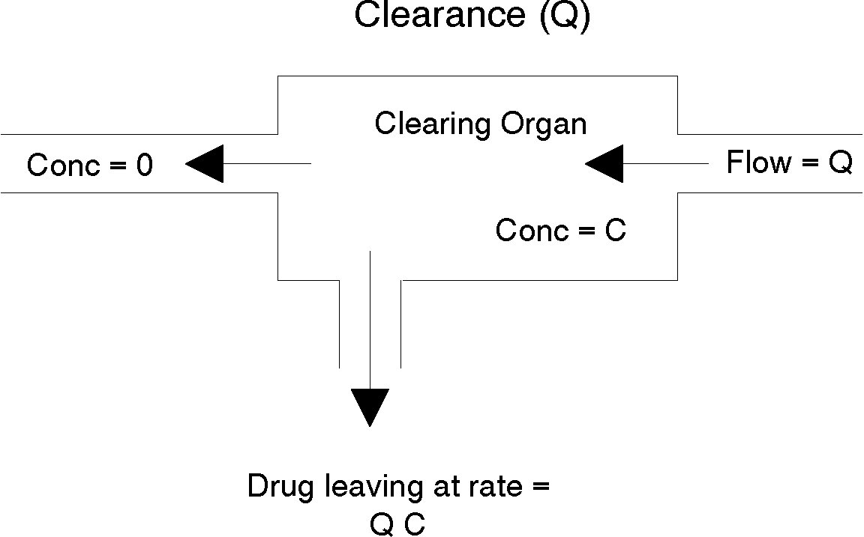Figure 3

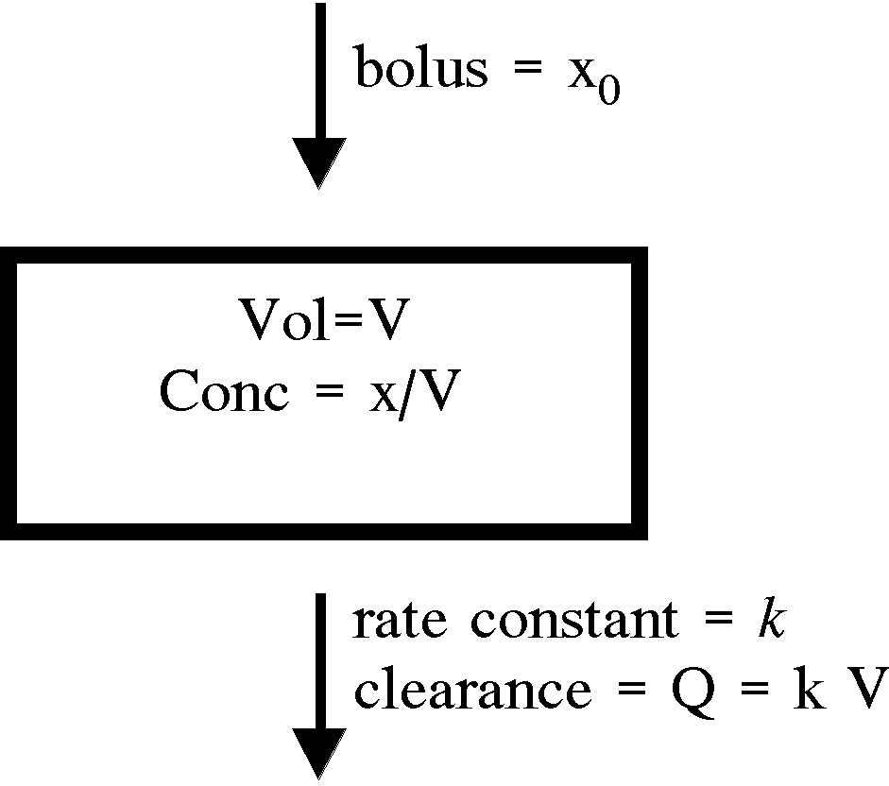
Figure 4

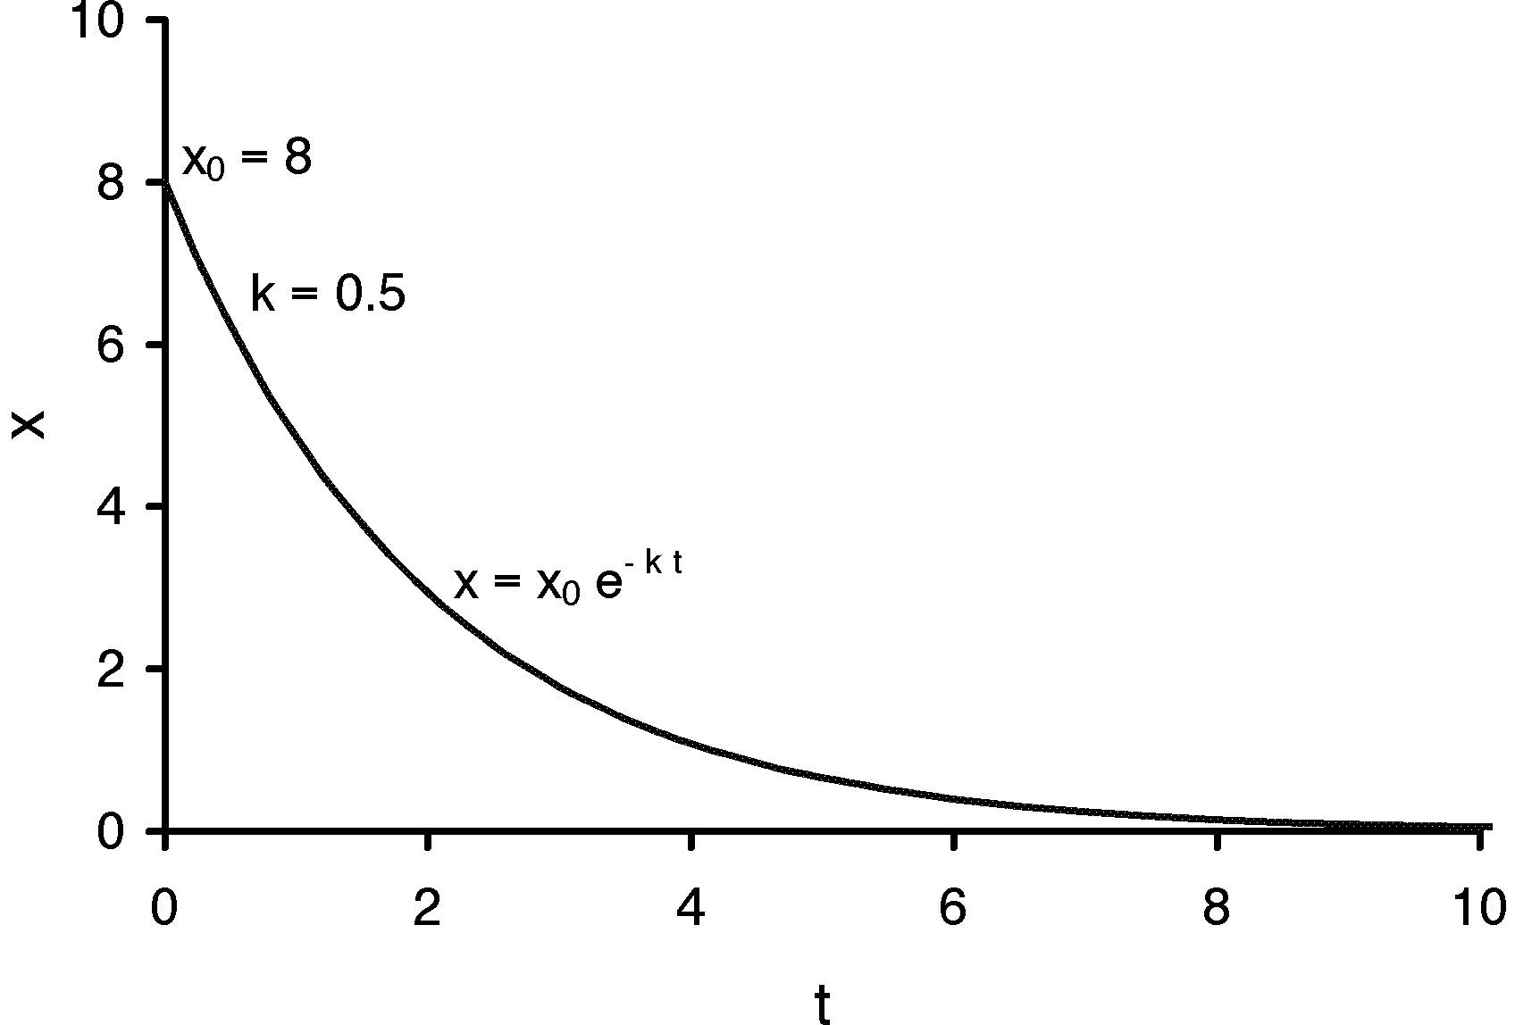Figure 5

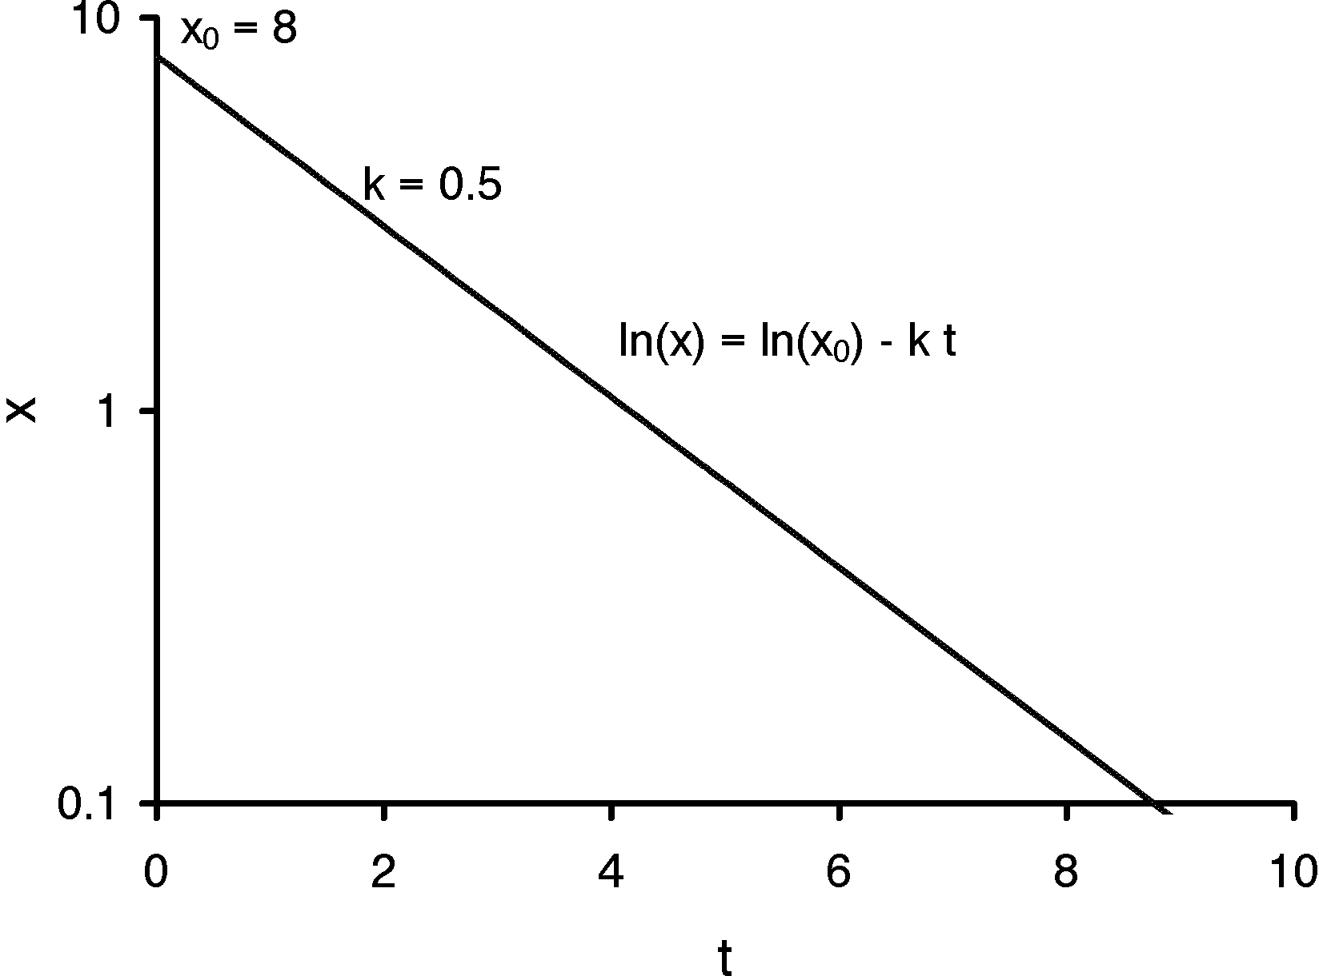

Figure 6

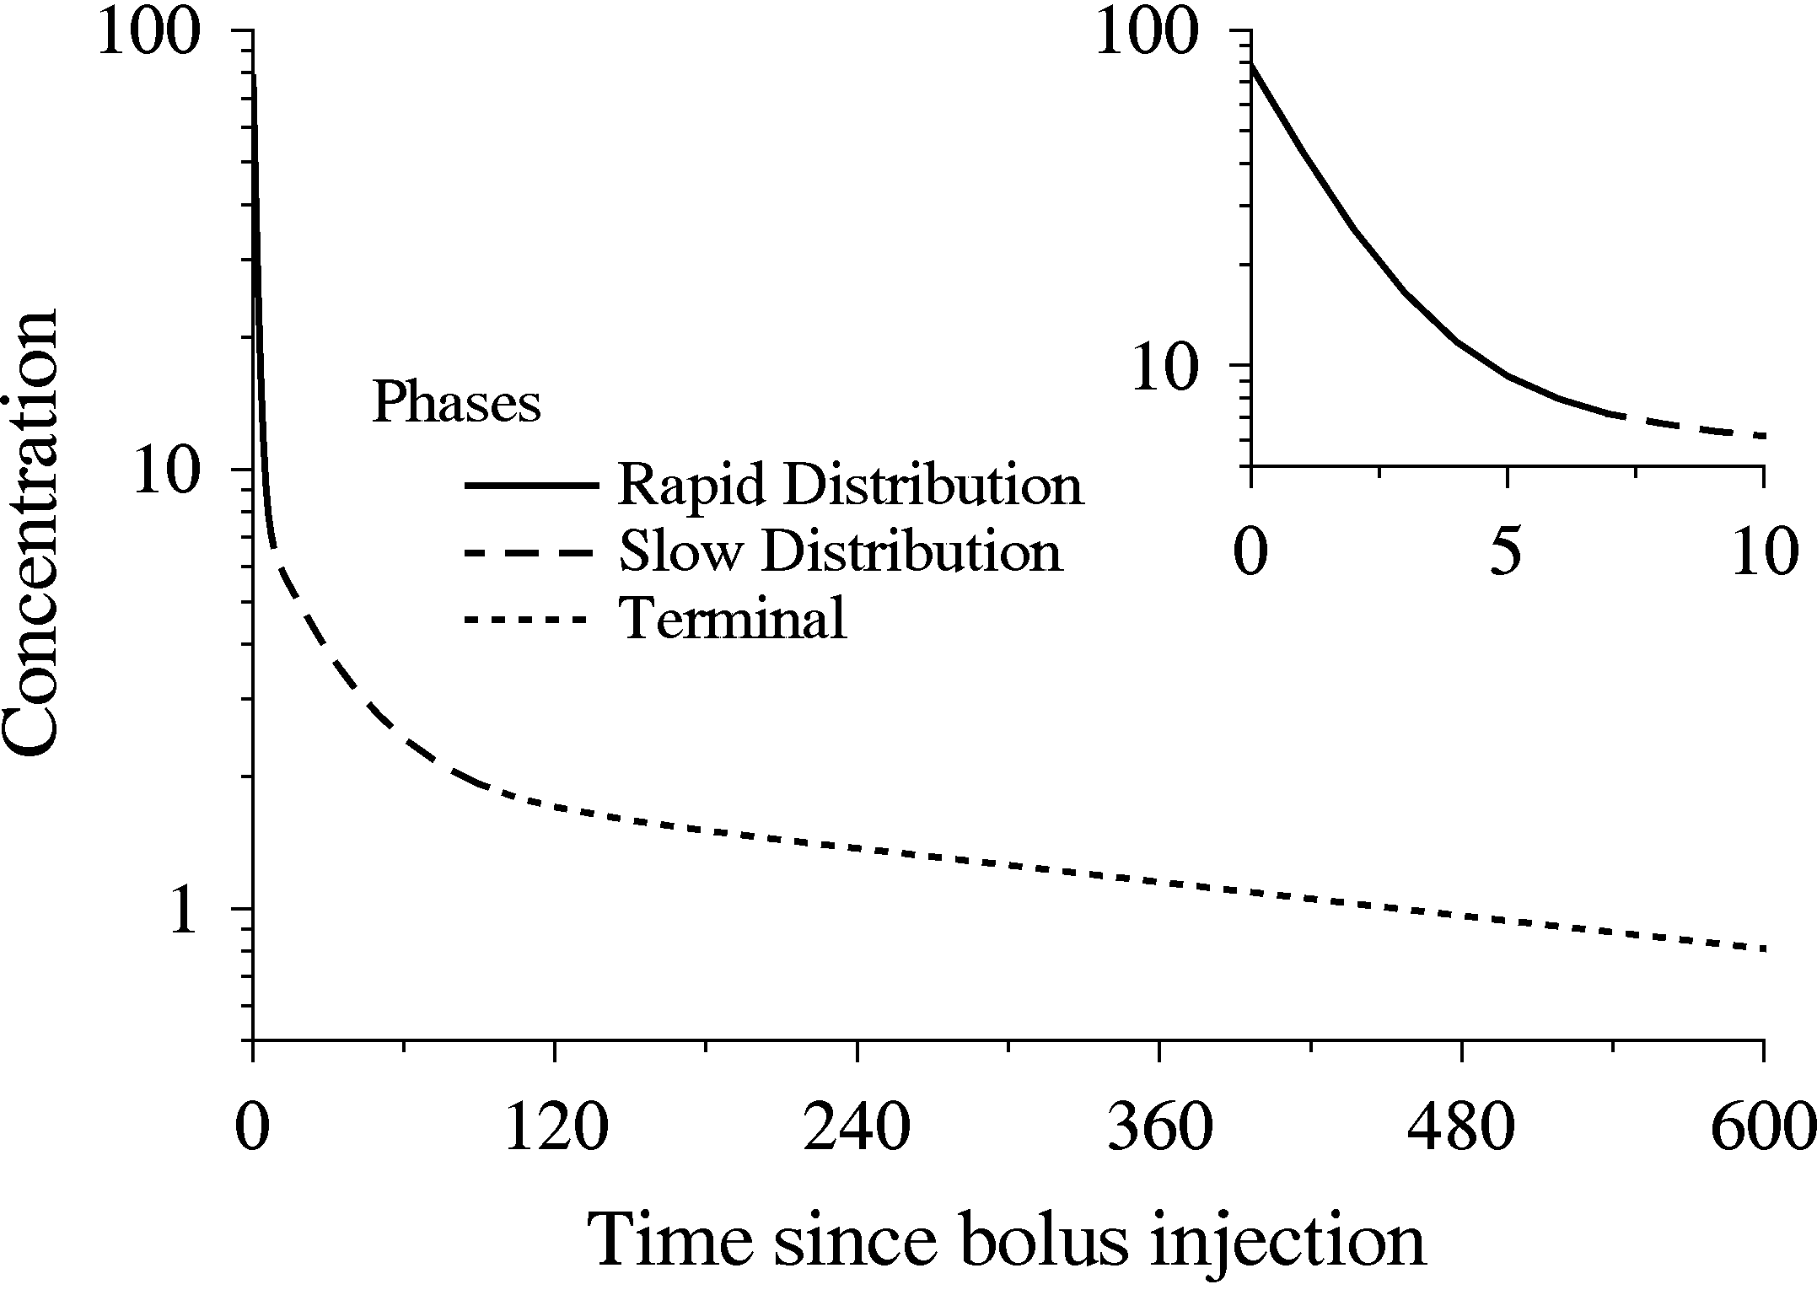

Figure 7

Figure 8

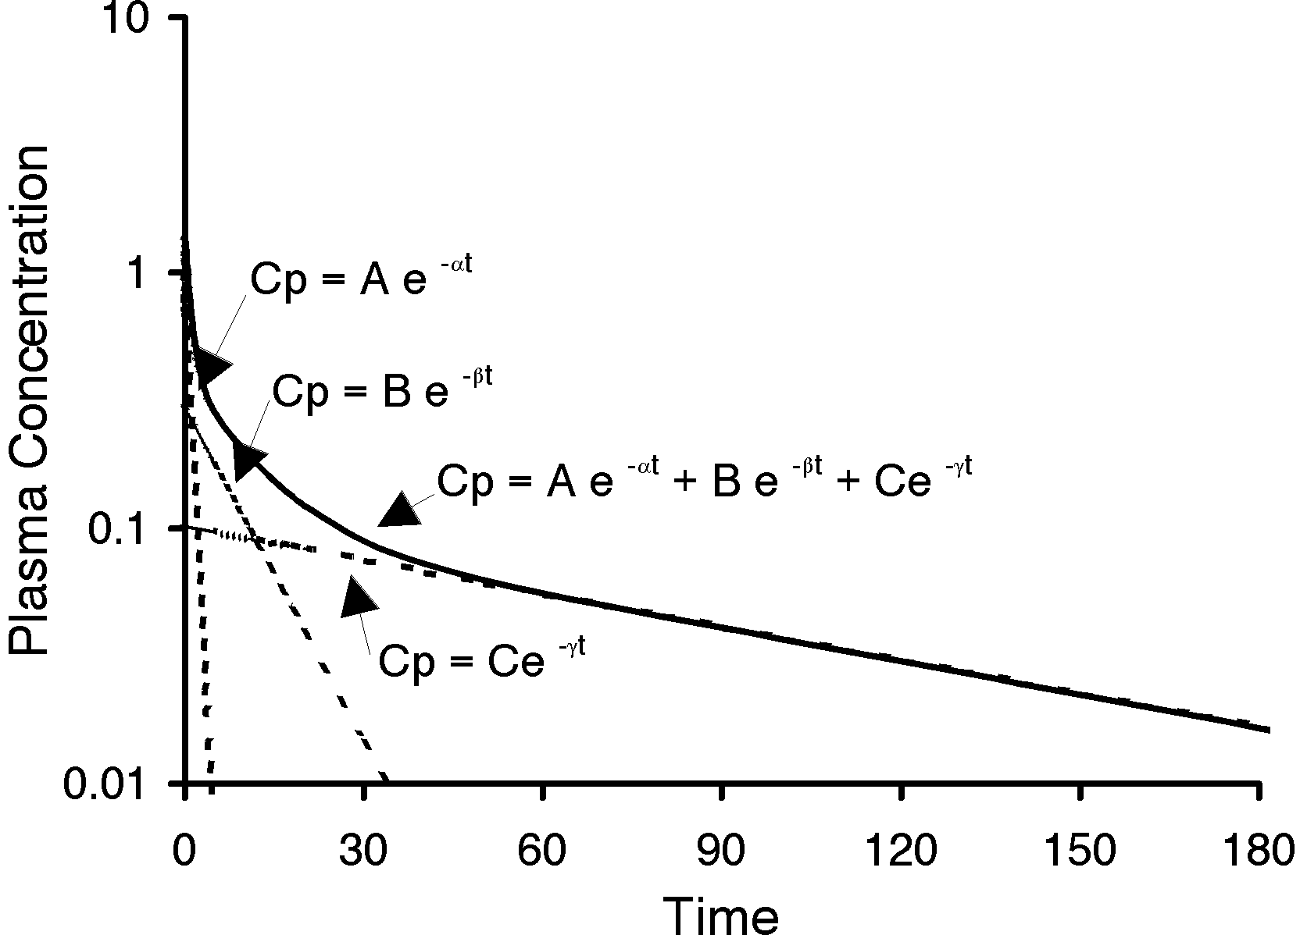

Figure 9
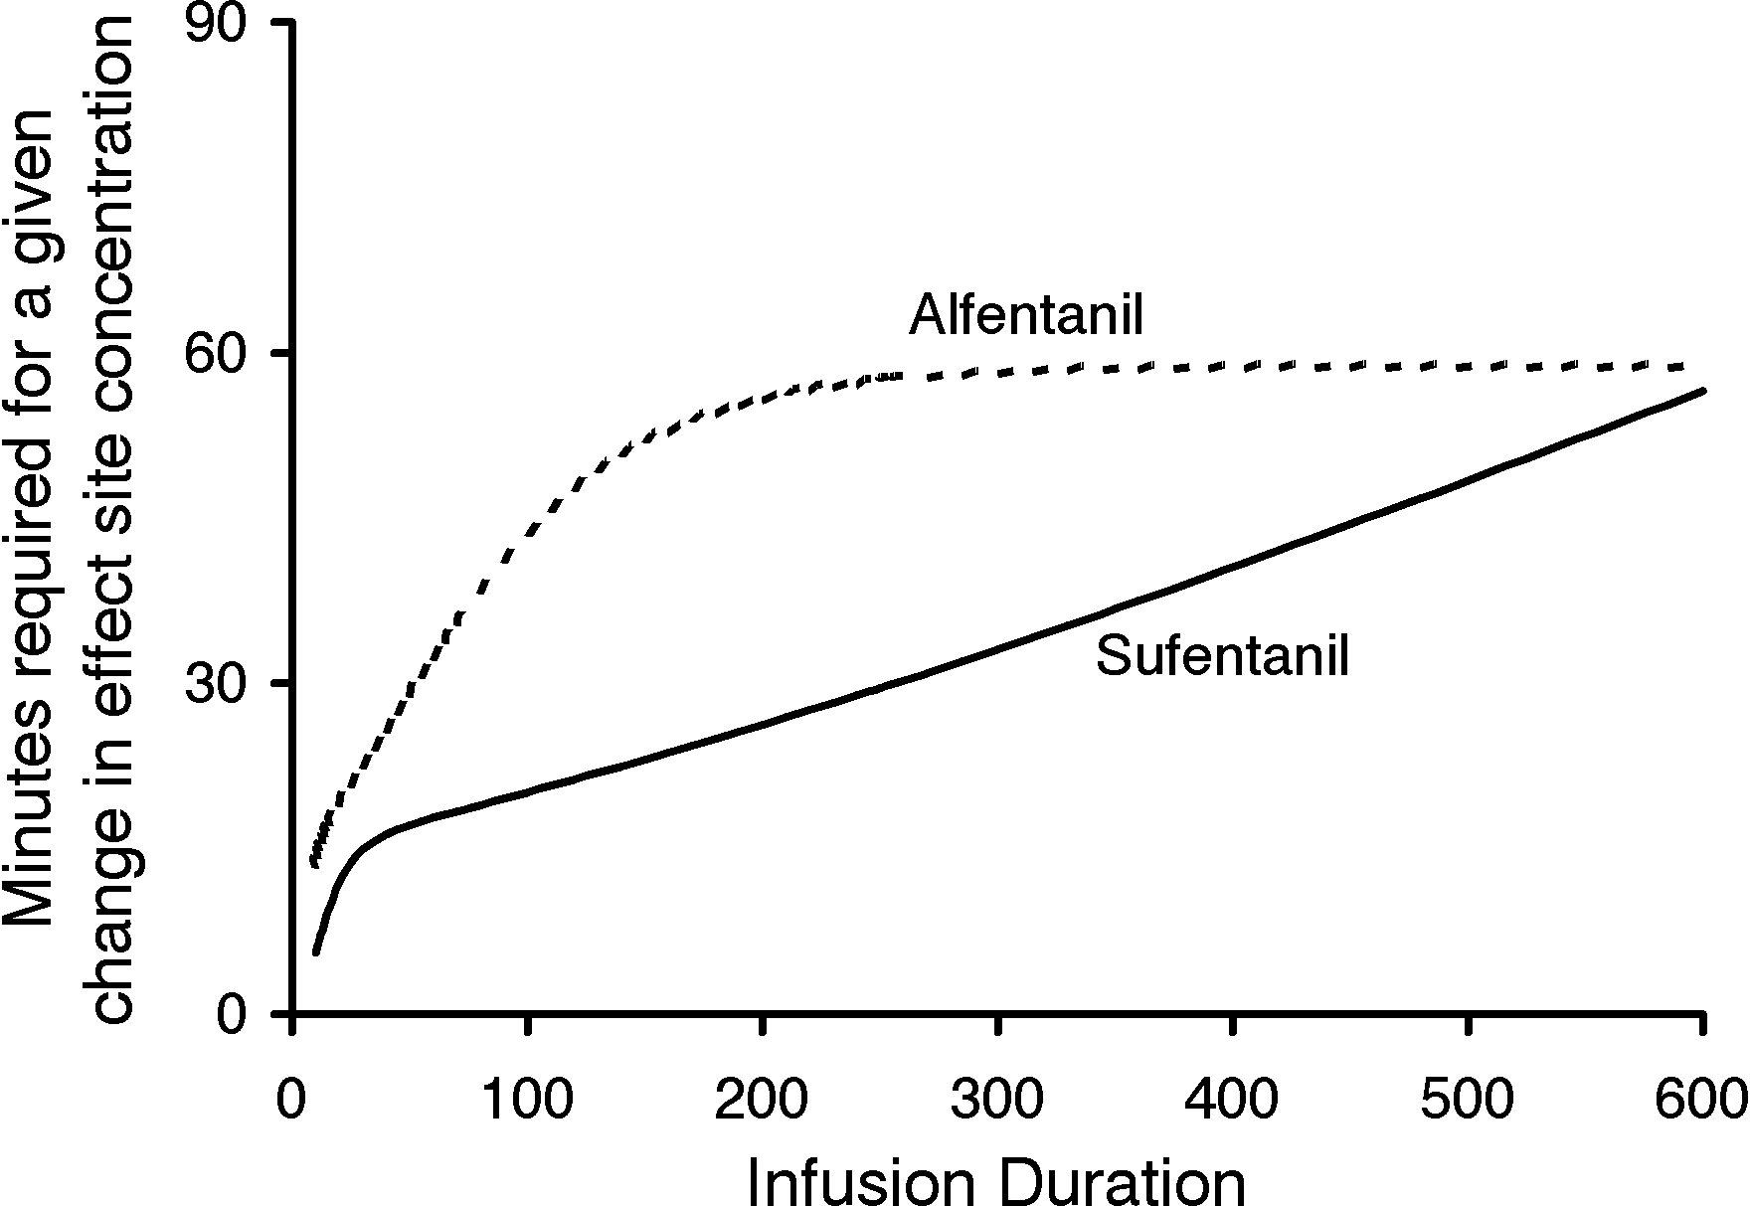Figure 10

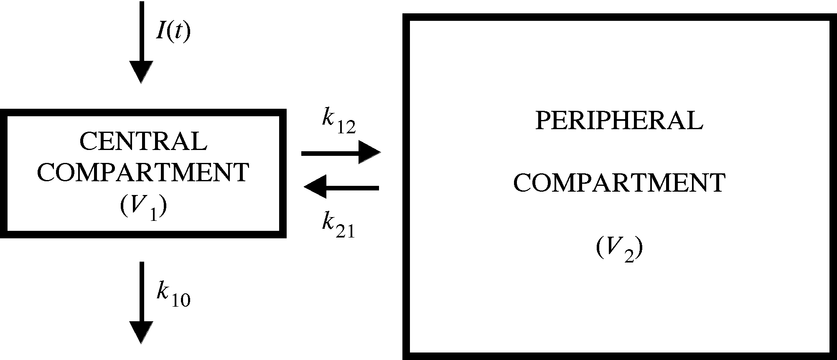

Figure 11

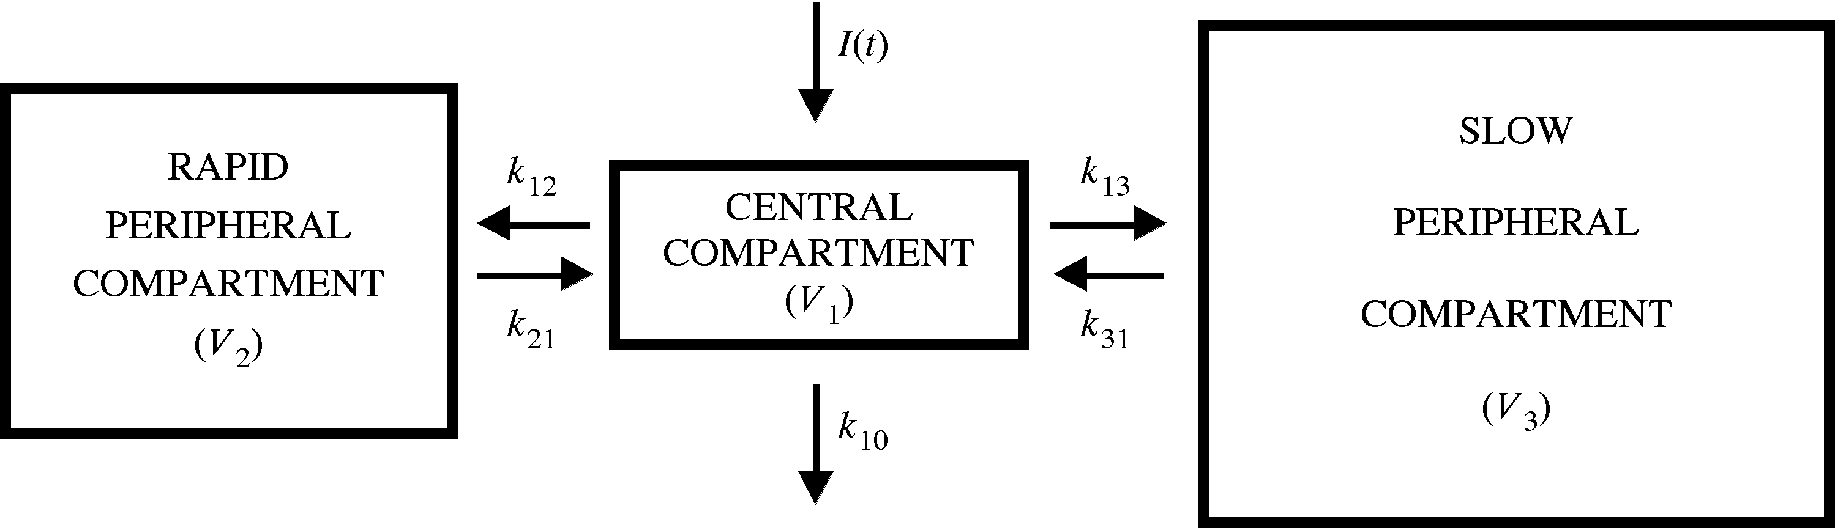

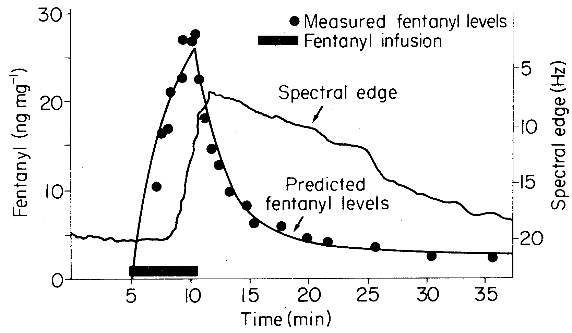
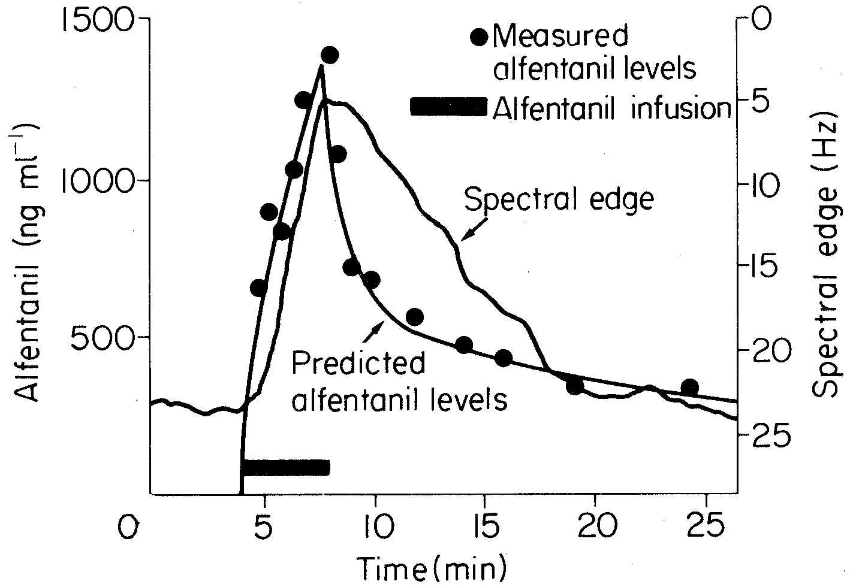
Figure 12
Figure 13

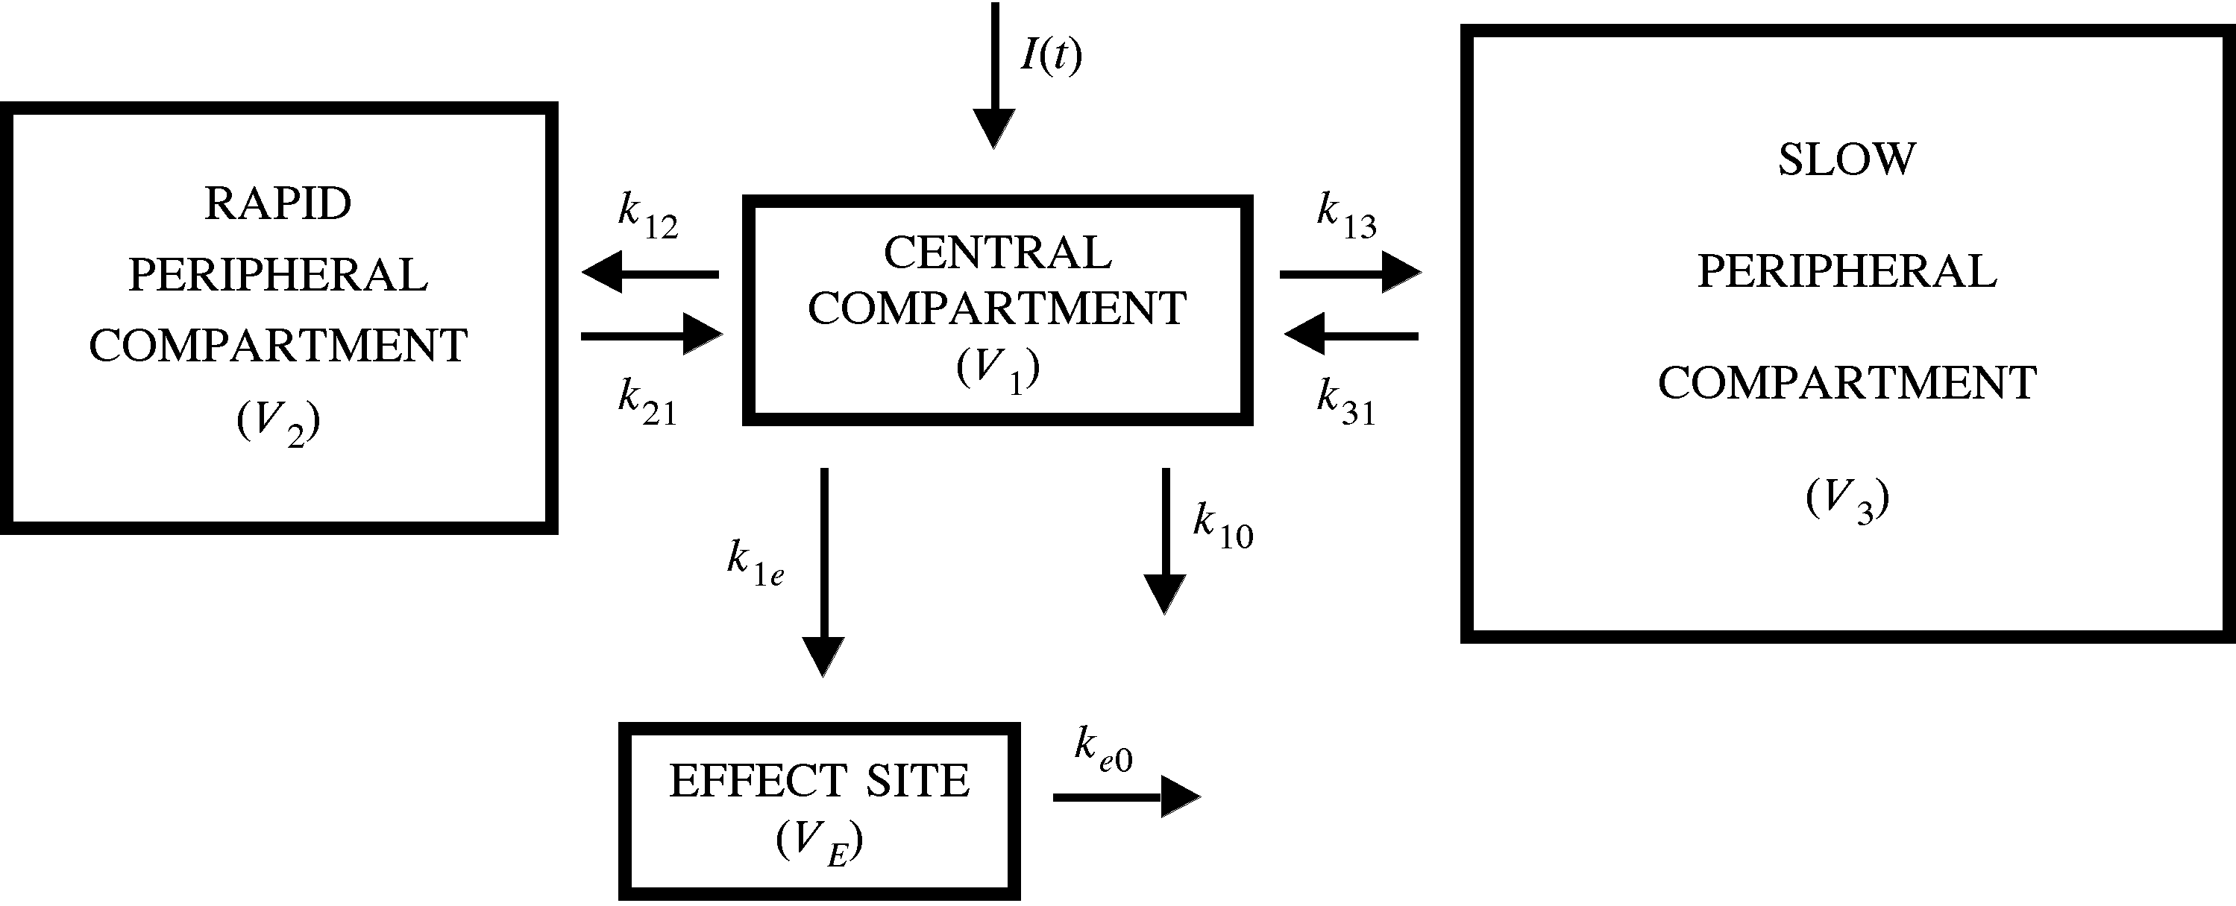

Figure 14

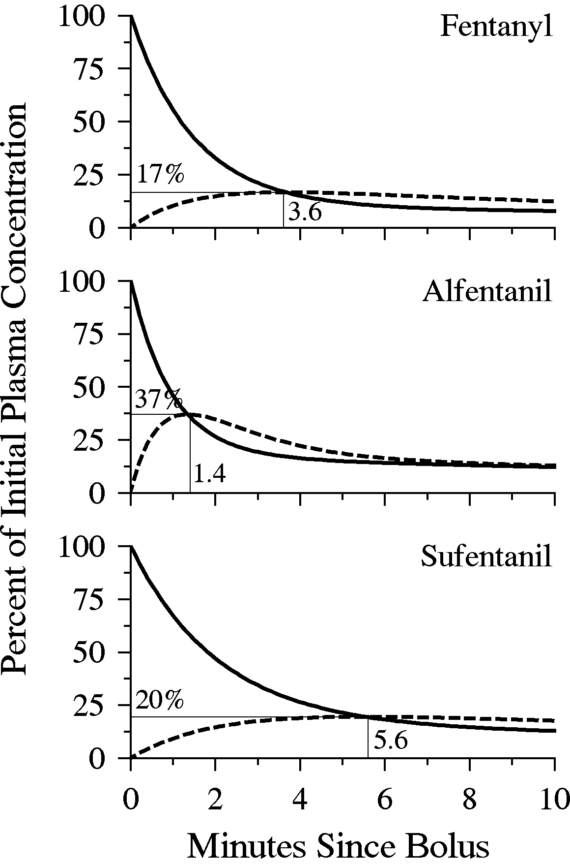

Figure 15

Figure 16

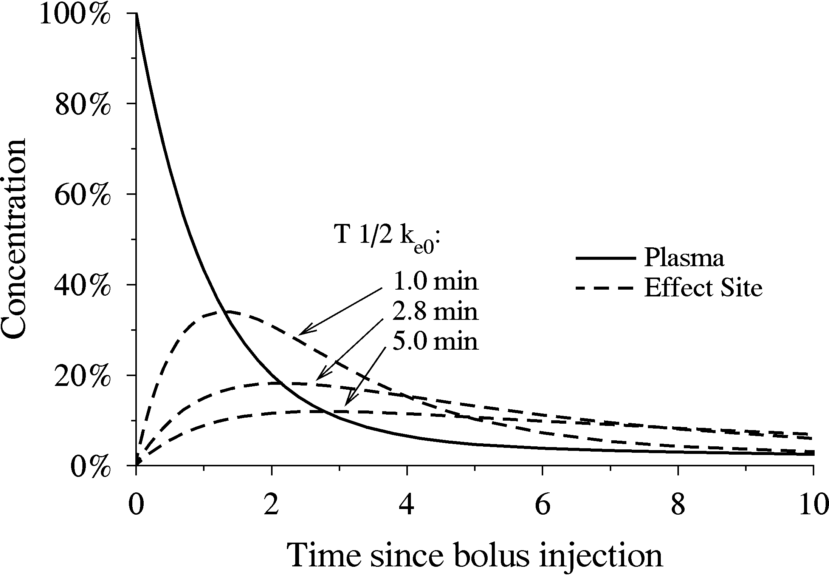

Figure 17

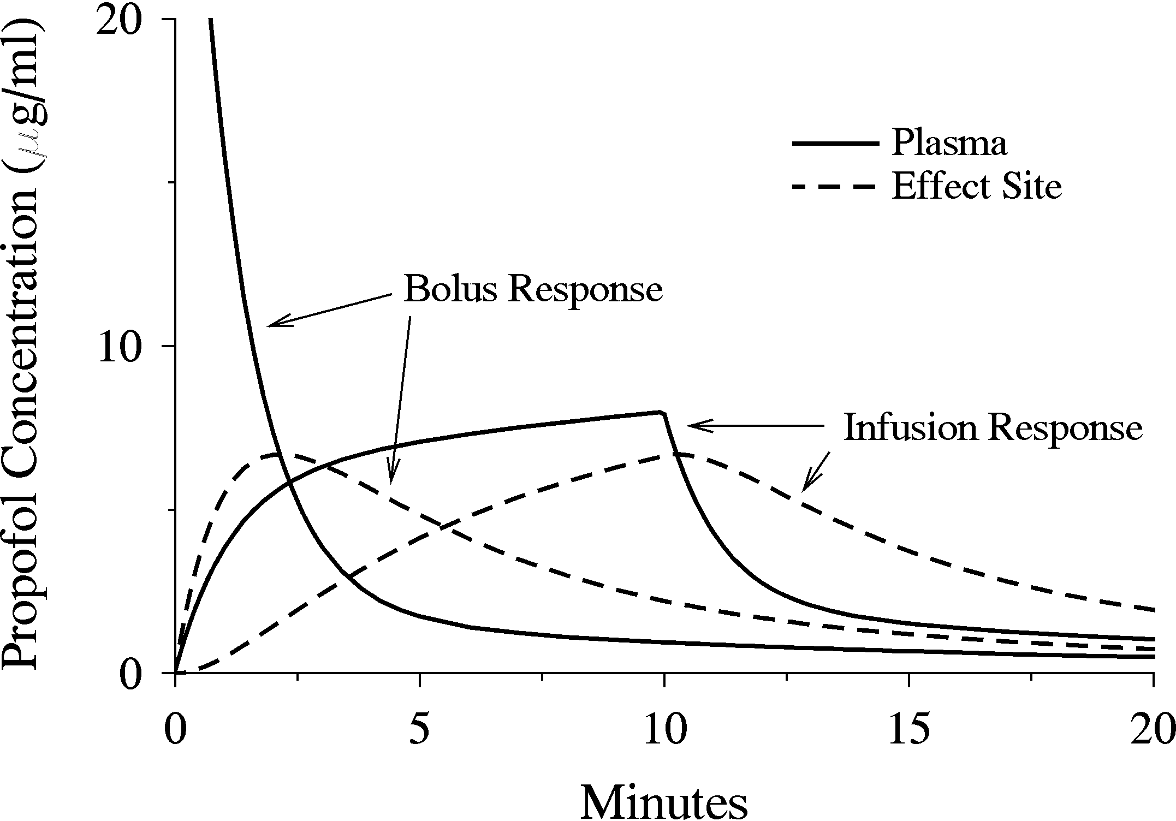
Figure 18

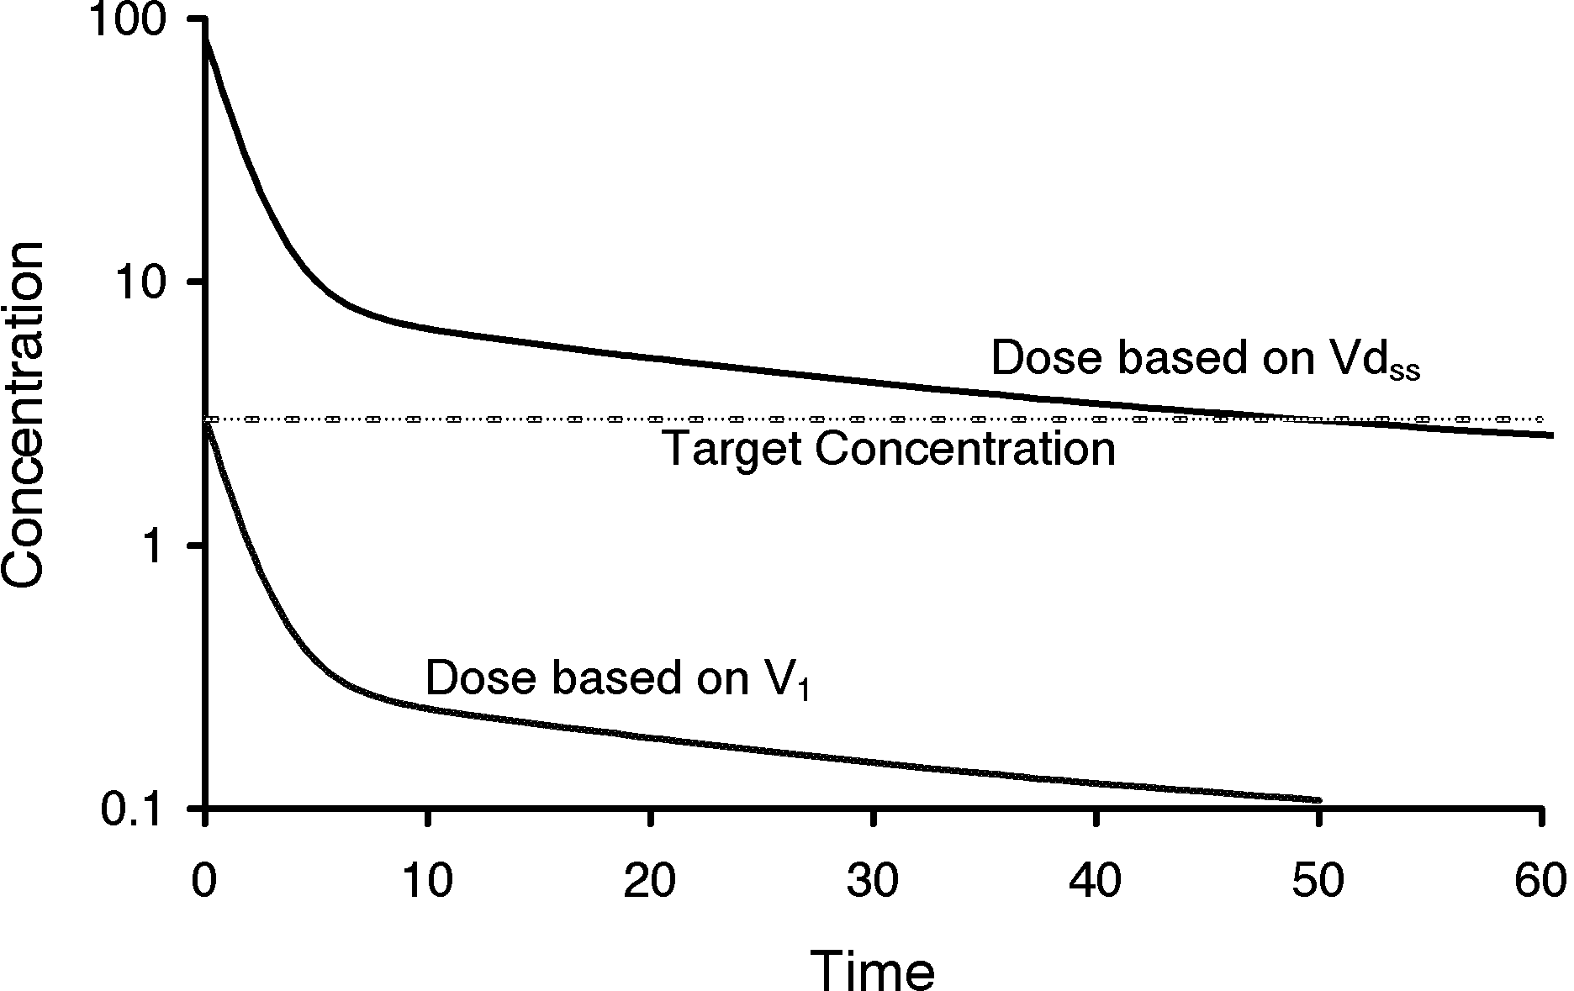

Figure 19

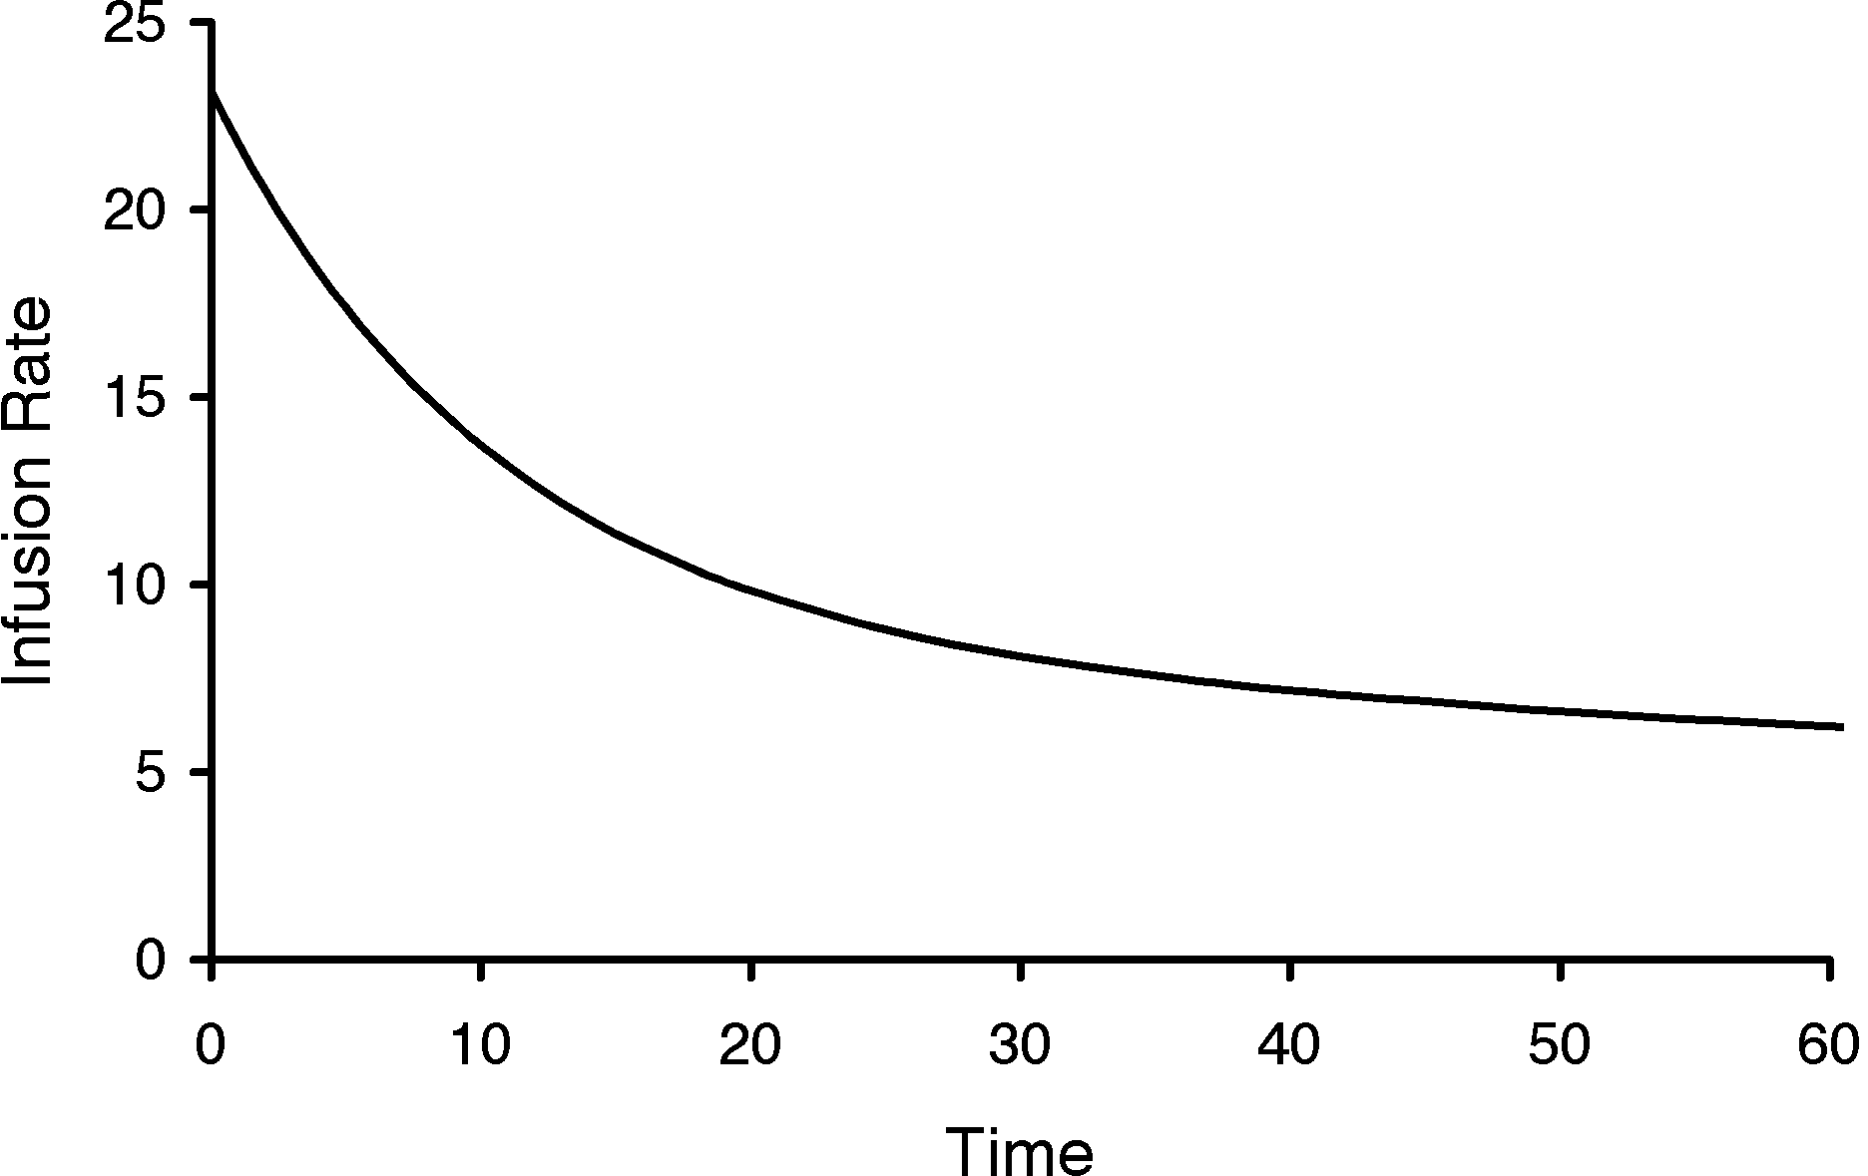Figure 20

Figure 21

Figure 22

Figure 23

Figure 24

Figure 25

Figure 26

Figure 27

Figure 28
Figure 29
References

* * "ln" refers to the natural logarithm in base e.
STANPUMP source and executable code can be downloaded from http://pkpd.icon.palo-alto.med.va.gov.
. Kruger-Thiemer E. Continuous intravenous infusion and multicompartment accumulation. Eur J Pharmacol 4:317-324, 1968
. H Schwilden: A general method for calculating the dosage scheme in linear pharmacokinetics. Eur J Clin Pharmacol 20:379-383, May, 1981
. Schuttler J, Schwilden H, Stoekel H. Pharmacokinetics as applied to total intravenous anaesthesia. Practical implications. Anaesthesia 38 Suppl:53-56, 1983
. Ausems ME, Stanski DR, Hug CC. An evaluation of the accuracy of pharmacokinetic data for the computer assisted infusion of alfentanil. Br J Anaesth 57:1217-1225, 1985
. Alvis JM, Reves JG, Govier AV, Menkhaus PG, Henling CE, Spain JA, Bradley E. Computer-assisted continuous infusions of fentanyl during cardiac anesthesia: comparison with a manual method. Anesthesiology 63:41-49, 1985
. Shafer SL, Siegel LC, Cooke JE, Scott JC: Testing computer controlled infusion pumps by simulation. Anesthesiology 68:261-266, 1988
. Jacobs JR. Analytical solution to the three-compartment pharmacokinetic model. IEEE Trans Biomed Eng 1988 Sep;35(9):763-765
. White M, Kenny GN. Intravenous propofol anaesthesia using a computerised infusion system. Anaesthesia 45:204-209, 1990
. Shafer SL, Varvel JR: Pharmacokinetics, pharmacodynamics, and rational opioid selection. Anesthesiology 74:53-63, 1991
. Hughes MA, Glass PSA, Jacobs JR: Context-sensitive half-time in multicompartment pharmacokinetic models for intravenous anesthetic drugs. Anesthesiology 76:334-341, 1992
. Maitre PO, Shafer SL. A simple pocket calculator approach to predict anesthetic drug concentrations from pharmacokinetic data. Anesthesiology 73:332-336, 1990
. Scott JC, Stanski DR: Decreased fentanyl/alfentanil dose requirement with increasing age: A pharmacodynamic basis. J Pharmacol Exp Ther 240:159-166, 1987
. Sheiner LB, Stanski DR, Vozeh S, Miller RD, and Ham J: Simultaneous modeling of pharmacokinetics and pharmacodynamics: Application to d-tubocurarine. Clin Pharmacol Ther 25:358-371, 1979
. Hull CJ, Van Beem HB, McLeod K, Sibbald A, Watson MJ. A pharmacodynamic model for pancuronium. Br J Anaesth 50:1113-1123, 1978
. Homer TD, Stanski DR: The effect of increasing age on thiopental disposition and anesthetic requirement. Anesthesiology 62:714-724, 1985
. Stanski DR, Maitre PO: Population pharmacokinetics and pharmacodynamics of thiopental: the effect of age revisited. Anesthesiology 72:412-422, 1990
. Buhrer M, Maitre PO, Crevoisier C, Stanski DR: Electroencephalographic effects of benzodiazepines. II. Pharmacodynamic modeling of the electroencephalographic effects of midazolam and diazepam. Clin Pharmacol Ther 48:555-567, 1992
. Scott JC, Cooke JE, Stanski DR: Electroencephalographic quantitation of opioid effect: comparative pharmacodynamics of fentanyl and sufentanil. Anesthesiology 74:34-42, 1991
. Billard V, Gambus PL, Chamoun N, Stanski DR, Shafer SL. A comparison of spectral edge, delta power, and bispectral index as EEG measures of alfentanil, propofol, and midazolam drug effect. Clinical Pharmacology and Therapeutics 61:45-58, 1997
. Donati F: Onset of action of relaxants. Can J Anaesth 35:S52-58, 1988
. Dyck GB, Shafer SL. Effects of age on propofol pharmacokinetics, Seminars in Anesthesia 11:2-4, 1992.
. Jacobs JR. Algorithm for optimal linear model-based control with application to pharmacokinetic model-driven drug delivery. IEEE Trans Biomed Eng 37:107-109, 1990
. Bailey J, Shafer SL. A simple analytical solution to the three compartment pharmacokinetic model suitable for computer controlled infusion pumps. IEEE Trans Biomed Eng 38:522-525, 1991
. Shafer SL, Gregg KM. Algorithms to rapidly achieve and maintain stable drug concentrations at the site of drug effect with a computer controlled infusion pump. J Pharmacokinet Biopharm 20:147-169, 1992

